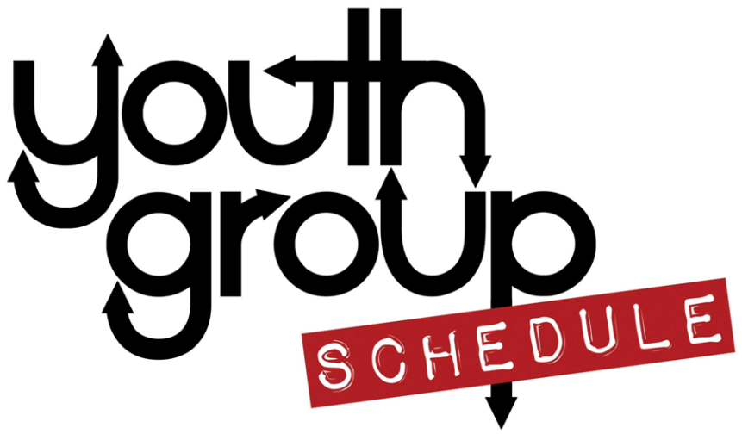
First Christian Church
Bloomington, Illinois
Holly Irvin
Director of Youth and Music

Fall 2018

September 16 – Back to School Food & Games@FCC (come dressed for sports)
September 23 – Youth Series begins – T.B.D. Prayer – between September and November we will learn, talk about, and DO prayer.
October 7 – cancelled (for Columbus Day)
October 14 – Youth Group with KFC – We will make prayer journals
October 19-20 Regional Assembly Youth Event

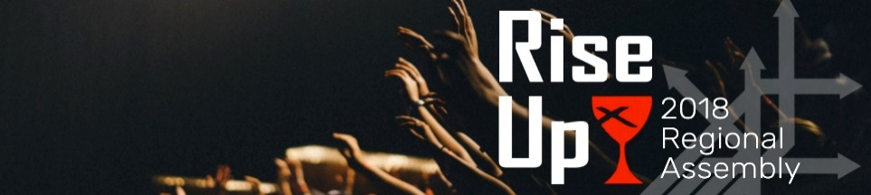
Friday night gathering of youth from around the region!
Saturday workshops, meal, youth events. Cost TBD
Schedule on youth board or online@cciwdisciples.org

October 20th Children/Youth sing for Regional Assembly Worship
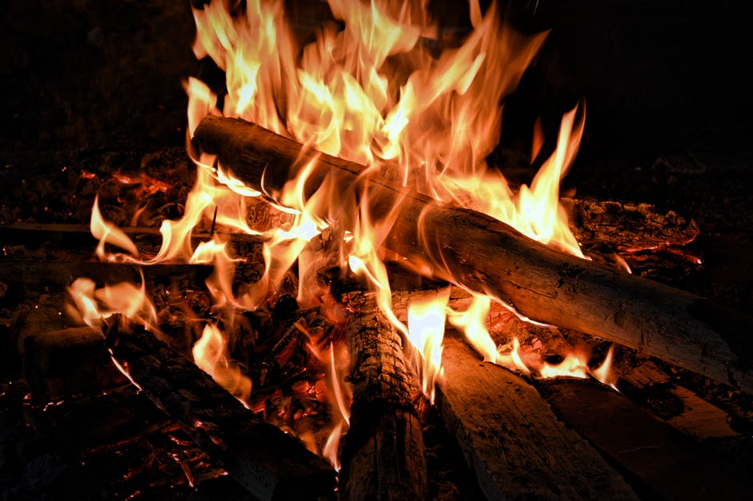
October 21 – cancelled (Regional Assembly)
October 28 – Bonfire
November 4 – Youth Group with KFC-Prayer
Walk – wear appropriate clothing for outside.
November 25 – cancelled (Thanksgiving)

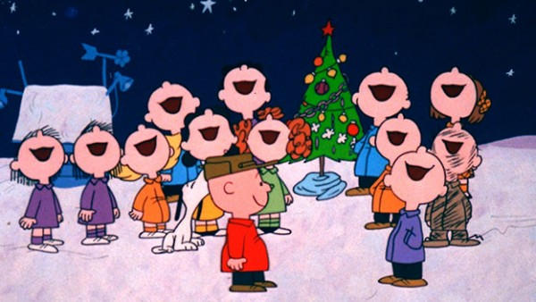

December 2 -Youth with KFC Caroling/Dinner
December 9 Youth with KFC Christmas Party
December 16,23,30 -cancelled (Christmas break)

We will sometimes provide snacks during Youth Group but are no longer providing a meal. Please keep that in mind.
Please fill out a permission form available on the Youth Board. It is good for the school year.

