Batesville, IND – In celebration of Earth Day, the City of Batesville, Batesville Main Street, and Batesville Area Chamber of Commerce are inviting businesses, residents, organizations, and schools to work together to make Batesville a litter-free community. We need volunteers to provide a helping hand in beautifying our city during the two-day community cleanup on Friday, April 21, and Saturday, April 22 from 8 am - 12 pm.
Interested volunteers can email one of the three community partners listed below. Sign-up is optional, you are welcome to show up during the two-day event and help out in any capacity you can.
On Friday, April 21st volunteers will meet at 8 am at Inspiration Park (across from Amack's Well), and on Saturday, April 22nd the meeting place will be at 8 am at Liberty Park Pavilion (716 S. Park Ave.). Further directions will be given out to volunteers upon arrival. Trash bags will be provided but please bring gloves and garden tools.
We encourage everyone to come out and have fun in the cleanup process by posting your cleanup selfie with #BvilleTeamUp2Cleanup on your social media.
On Saturday, April 22nd at 1 pm the Batesville Skatepark Advocacy Group and the City of Batesville would like to invite everyone to the Grand Opening of the Batesville Skatepark and Outdoor Adventure. There will be a ribbon cutting for the skatepark and the new Batesville Trails at 1 pm along with music, food trucks, and Earth Day giveaways. For more information https://www.facebook.com/profile.php?id=100063995797348

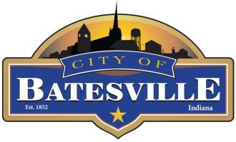
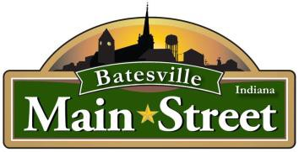

Tricia Miller
tmiller@batesville.in.gov www.batesvilleindiana.us 812-569-5904

Amy Pretzer
batesvilleinmainstreet@gmail.com www.batesvillemainstreet.org 407-625-7911

Melissa Tucker
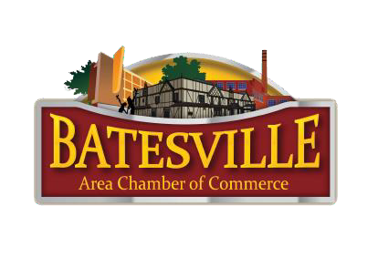
chamber@batesvillein.com www.batesvillein.com
812-934-3101

