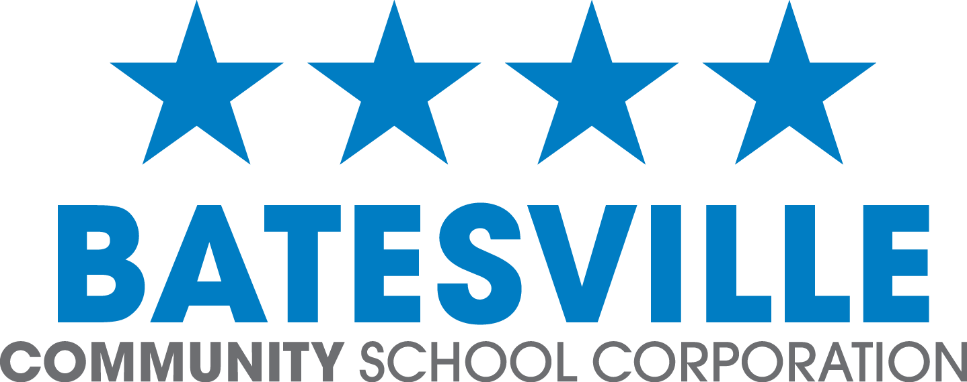

P.O. Box 121, 626 North Huntersville Road, Batesville, IN 47006 batesvilleinschools.com T: 812-934-2194 F: 812-933-0833

FOR IMMEDIATE RELEASE
Contact: Andy Allen
Email: aallen@batesville.k12.in.us
Phone: 812-934-4384
BHS ANNOUNCES PLANS FOR $500K EXCELLENCE GRANT

BATESVILLE, INDIANA — The celebrations have turned into strategy sessions as Batesville High School (BHS) begins to make decisions about how best to allocate the $500,000 it will receive as the top recipient of the Indiana Department of Education’s (IDOE) Excellence in Next Level Educational Experiences and Opportunities grant. As one of three state finalists for this award, BHS was guaranteed $250,000, which was subsequently matched dollar-for-dollar by the state after the results of an online voting competition resulted in Batesville receiving the most support.

“Thanks to the overwhelming response from supporters of the Batesville Community School Corporation (BCSC) to an online voting opportunity on September 8, BHS was awarded this significant amount of money,” Andy Allen, BHS principal, said. “Cognizant that the community played a major role in our success, BCSC leadership has spent the last weeks carefully reviewing potential initiatives to support with the funds. The community came together to make this happen and we plan to be good stewards by supporting programs that will make a strategic, lasting impact for Batesville Bulldogs.”

While discussions are still underway, initial grant funding ideas include:
- Support for the Bulldog Ready educational transformation that includes evolving professional responsibilities, leadership development opportunities, and further community involvement;
- Expansion of Project Lead the Way programming at BHS and the introduction of this engineering initiative at Batesville Middle School (BMS);
- Ongoing support for the Batesville Innovation Center, currently under construction on the BHS campus;
- An extended commitment to the corporation’s current wellness initiative, servicing all BCSC staff and students;
- Focused leadership development programs to align with Batesville’s Bulldog Ready process and strategic plan; and

-MORE-
- Staff professional development opportunities centered on the following:
  - Literacy and the Science of Reading; Leadership Development; Innovation, Creativity, and Wellness;
  - Teacher externship opportunities; and
  - Targeted staff certifications.

“This grant will allow us to invest more in students and teachers, transforming teaching and learning,” added Allen. “The timing couldn’t have been better, with the construction of the BHS Innovation Center underway and the community involvement in the Bulldog Ready process ramping up. We embrace our responsibility to ensure that the grant dollars spent enhance what we can accomplish at BCSC.”

-###-

