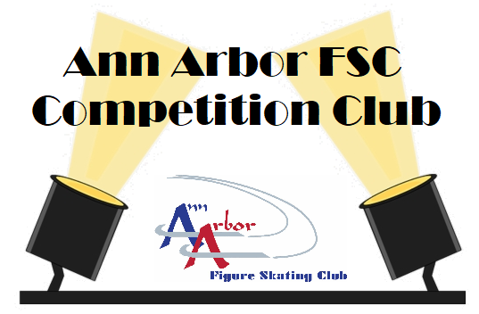

Competition & Performance Club

Winter 2022 Session Dates
Sunday, January 9th - Sunday, March 6th
To register, please visit www.annarborfsc.org

Located in the Ann Arbor Ice Cube
2121 Oak Valley Drive
Ann Arbor, MI 48103
(734) 213-6768

Class Information

Competition and Performance Club is designed to train and prepare skaters currently enrolled in AAFSC's LTS program for participation in the Michigan Basic Skills competition series (MBSS) and other performance opportunities throughout the year. Skaters in this group class will prepare for a competition event at their level, learn the process of competing and performing, and participate in a local Basic Skills competition or AAFSC club performance opportunity. The program is intended to introduce skaters to the excitement of competing and performing, build confidence in individual skating skills, and foster feelings of accomplishment and good sportsmanship. Open to all AAFSC Basic Skills members and/or Ann Arbor Figure Skating Club members.

Your skater will receive 50 minutes of skating time utilizing the full ice with instruction. Plus, registration for two events in the Mountain Town Classic Basic Skills Competition in Mt. Pleasant, MI on Saturday, March 12th.
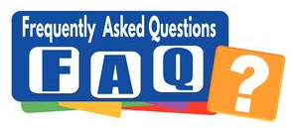

AAFSC Refund and Credit Policy
- There will be NO refunds issued for Learn to Skate classes.
- If a skater drops the class within 14 days of the start of the regular scheduled session, a credit will be issued to the skater’s account. After 14 days, a class can be dropped only for medical reasons with a doctor’s note. All credits will be prorated from the date the class is dropped.
- Administrative and competition fees will not be refunded or credited.
- Please contact the AAFSC Office if you wish to drop a Learn to Skate class.

Registration Requirements
    - All Competition Club skaters MUST be a 2021-2022 AAFSC Basic Skills member or a member of the Ann Arbor Figure Skating Club.

Equipment
    - Rental skates and helmets are available for all classes at no extra charge. Helmets and skates are limited in number and are available on a first come basis. Feel free to bring our own bike, hockey, or all-sports helmet to class.
    - Helmets are strongly recommended for skaters under 5 years of age and all beginning skaters.
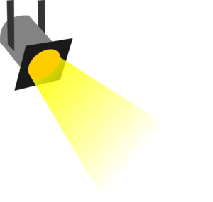

Competition & Performance Club
Winter - 2022

COMPETITION & PERFORMANCE

CLUB COORDINATOR
Brad Newman
bradnewman50@gmail.com

LEARN TO SKATE COORDINATOR

Mary Johanson

coachmaryjohanson@gmail.com

ANN ARBOR FSC OFFICE
Phone: 734-213-6768
Email: aafsc@annarborfsc.org
Sundays 1:15 pm - 2:05 pm

January 9th – March 6th

9 classes + Competition fees = $360
1/9, 1/16, 1/23, 1/30, 2/6, 2/13, 2/20, 2/27, 3/6

Included in Registration for Winter Session
Entry for the
Mountain Town Classic Basic Skills
in two (2) events
held in Mt. Pleasant, MI
on Saturday, March 12th

ATTENTION: You must be an Ann Arbor Figure Skating Club or Learn to Skate Member to participate in our classes. Membership is $35.00 annually and runs July 1st, 2021 to June 30th, 2022.

