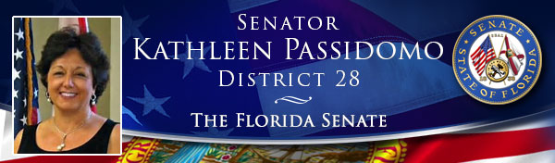
Newsletter: Committee Week 2
During our 2nd week of Committee Meetings in Tallahassee, the Senate continued our discussions on Hurricane Irma and the opioid epidemic. I was also pleased to see a few familiar faces from Collier and Hendry Counties in my Senate Subcommittee on Pre K-12 Education Appropriations.

Appropriations Committee
In the Senate Appropriations Committee we received an update on Hurricane Irma recovery efforts from Wes Maul, the Florida Director of Emergency Management, and Governor Scott’s Budget Director, Cynthia Kelly. Both were on hand to present budgetary numbers and answer questions on the state’s recovery efforts. Ms. Kelly presented preliminary state budget impact estimates for the various state agencies. She also explained the state’s expectations for federal reimbursement for state expenditures. Director Maul provided an update regarding recovery and local reimbursement efforts. The Committee stressed to Mr. Maul that FEMA reimbursement process has been lengthy in the past and I pointed out that Collier County is still waiting for reimbursement for certain costs from Hurricane Wilma. Director Maul informed the Committee that his staff is doing all they can to provide clarity and speed the reimbursement process up and agreed to meet with Collier County officials to discuss the Wilma reimbursement.
Trey Price, the Executive Director of the Florida Housing Finance Corporation also presented to the committee. Mr. Price discussed some of the Hurricane Irma related efforts including their partnership with FEMA on an Augmented Housing Locator Service. Floridians can visit the website, www.FloridaHousingSearch.org, where they can use an affordable rental housing locator service that can help to find either temporary or permanent housing options.

Appropriations Subcommittee on Health and Human Services
In the Appropriations Subcommittee on Health and Human Services, we continued our discussion on the opioid epidemic, and heard from a panel of professionals in the healthcare field.
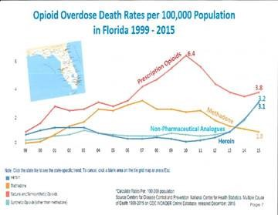
The panelists included: Jim Hall, a Senior Epidemiologist at the Center for Applied Research on Substance Use and Health Disparities Nova Southeastern University, John Bryant, the Assistant Secretary for Substance Abuse and Mental Health at the Florida Department of Children and Families, Beth Kidder, the Deputy Secretary for Medicaid at the Agency for Health Care Administration and Maggie Labarta, Ph.D., CEO of Meridan Behavioral Healthcare, Inc.
The panelists all provided testimony from their own experiences and discussed how the opioid crisis has affected our state. They each gave lawmakers suggestions about to what we can do to combat the issue that they described as a ‘perfect storm.’ Some of the recommendations from the panelists included: Intensify prescribing requirements to weigh in over-prescription, intervention training for families, increasing treatment availability, medical assisted treatment, outpatient services, creating recovery support system for communities across Florida, and encouraging collaborative partnerships with community drug coalitions across state.
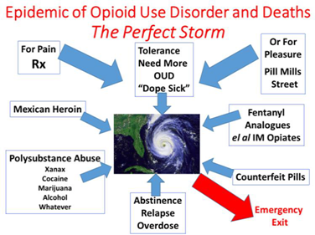
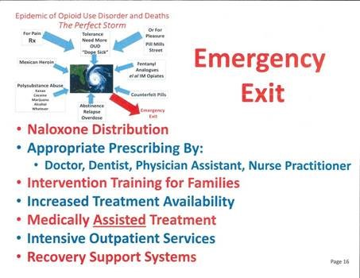

Senate Pre K-12 Subcommittee on Appropriations
In my Senate Pre K-12 Subcommittee on Appropriations we assembled two panels of education professionals to have a collaborative discussion with the Committee. These panels focused on Hurricane Irma related fiscal issues and mental health and substance abuse challenges that school districts are facing across Florida. From my district, Superintendent Kamela Patton from Collier County and Superintendent Paul Puletti from Hendry County came to the capitol to discuss the Hurricane’s impact, as well as mental health in schools.
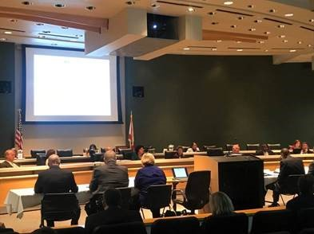
Chairing my Subcommittee on Pre K-12 Education Appropriations
The storm presented a number of challenges for schools throughout the state. Many more school facilities ended up serving as shelters than had originally been projected and many school employees were tasked to staff these shelters with such duties as distributing food, collecting and distributing donations and even performing home wellness visits. In Collier County alone, twenty-eight schools opened as shelters. Dr. Patton testified that based on their count, the school shelters in Collier County served over 17,000 people. The panelists from our Hurricane Irma discussion also testified on their preparedness efforts before the storm and on some of their experiences in the recovery process after the storm that included their efforts of returning the facilities to school use in a matter of hours.
The second panel discussed challenges that schools are facing in regards to mental health and substance abuse. One startling takeaway from the mental health panel was that one in five children and adolescents experience a significant mental health condition during their school years. Superintendent Puletti gave some perspective from a less-populated school district. He testified that although Hendry County has a small, rural population his district and students face the same problems as larger communities as students have cell phones and are on social media which can lead to the issue of cyber-bullying.
Suicide is another issue that was discussed in the committee’s mental health discussion. According to the Florida Department of Children and Families, suicide has been the third leading cause of death for young Floridians between the ages of 10 and 24. There were 425 suicides in the 10-14 age range in 2014 alone. The committee also heard that involuntary commitments (Baker Act proceedings) of juveniles have increased by almost 50 percent in the last five years across Florida. These Baker Act commitments have increased by 170 percent in Collier County alone. Dr. Patton testified that the school district is working with the Collier County Sheriff’s Office, the David Lawrence Center and other local groups in order to make sure educators are trained to handle these challenges.
The topics from both panels also overlapped toward the end of our discussions as it was noted that some students have various emotional needs based on their experiences during disasters such as Hurricane Irma.
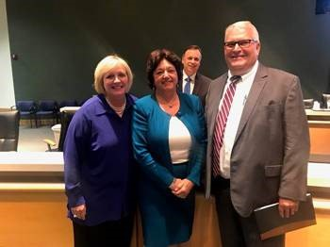
With Collier County Superintendent of Schools, Kamela Patton and Hendry County Superintendent of Schools, Paul Puletti.
ICYMI: Superintendent Patton’s Article in Florida Weekly on Hurricane Irma’s Impact on Collier County Public Schools
https://naples.floridaweekly.com/articles/schools-superintendent-reflects-on-irmas-impact/

Senator Bill Galvano designated as Senate President for 2019-2020 Legislative Term
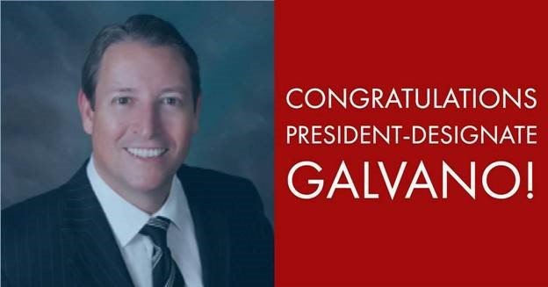
On Tuesday, October 24, Senator Bill Galvano was designated as the next President of the Florida Senate by the Senate Republican Legislative Caucus. Senator Galvano is a terrific public servant and someone I have been fortunate to work with during my time in the Legislature. Senator Galvano will serve our state well as the next President of the Florida Senate.
Read More on President-Designate Bill Galvano Here:
Article: Bill Galvano brings policy skills to top Senate Post
http://floridapolitics.com/archives/247604-bill-galvano-brings-policy-skills-top-senate-post
Video of President-Designate Galvano’s full acceptance speech can be viewed via the Florida Channel at the link below:
http://thefloridachannel.org/videos/102417-republican-senate-president-designationceremony-senator-bill-galvano/

Video archives of all Senate committee meetings from this week can be viewed online via: http://www.flsenate.gov/Media/Videos
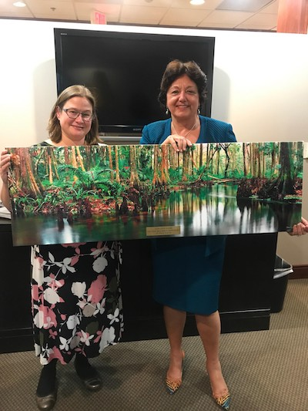
Receiving the Florida Chapter of the American Society of Landscape Architects’ 2017 Legislative Champion Award.

Please do not hesitate to contact me if I can be of assistance.
Sincerely,
Senator Kathleen Passidomo
District 28
P.S. Don't forget to connect with me online on Facebook and Twitter!
State Senator Kathleen Passidomo
3299 East Tamiami Trail
Suite 203
Naples, FL 34112
239-417-6205
25 East Hickpoochee Avenue
Room J-126
Labelle, FL 33935
863-674-7122
318 Senate Office Building
Tallahassee, FL 32339
850-487-5028

