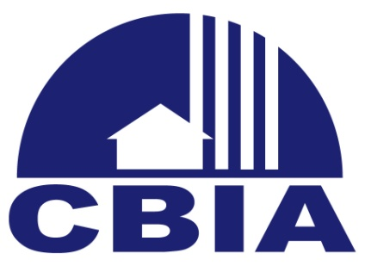 Potential 2018 State Legislative Issues

WORKERS’ COMPENSATION REFORM
Construction pays the highest rate in workers’ compensation premiums. A 14.4% rate increase means higher costs to build homes and increases are on the horizon. For every $1,000 increase to the cost of a home, an average of 20,000 affordable housing households are priced out of the home buying market. Real reform is necessary.

FHBA Position: Support reform to the worker’s compensation program, which results in meaningful rate reduction.

NOTICE AND RIGHT TO CURE
The Notice and Right to Cure statute was founded to encourage rehabilitation of construction defects before instituting tort actions. Unfortunately, the statute is not achieving the desired result. Many report that homeowners are unaware an offer to repair the damage was ever offered. Homeowners should be the ones who accept or reject offers to repair, not attorneys who stand to benefit by engaging in tort actions.

FHBA Position: Support legislation that requires the homeowner to personally accept or reject offers of repair.

FULL FUNDING OF SADOWSKI HOUSING TRUST FUND
For the last several years, monies have been taken from the Sawdowski trust fund to provide financial resources for other state programs. Full funding of the trust

fund provides an economic benefit of well over $3 billion and creates nearly 30,000 jobs while providing safe and affordable homes.

FHBA Position: Support full funding of the Sadowski trust fund and/or legislation that requires Sadowski monies to be spent on its designated purpose.

CONSTRUCTION WORKFORCE
Though the housing market has rebounded from the depths of a depression, a major impediment to maintaining the current building tide is the critical lack of a skilled workforce. Several states have been successful in growing their construction workforce by providing funding to consistently educate the public about careers in construction. Many kids and parents hold a negative opinion about the ability to make a good living in the construction trades. This perception must change.

FHBA Position: The FHBA supports Legislation establishing a permanent Construction Workforce Consortium with a dedicated funding source, a small portion of the building code surcharge, to educate about careers in construction.

COLLECTION OF IMPACT FEES
At least one local government is now collecting impact fees at the time of platting. The additional carrying costs resulting from this unjustified early time of collection will result in increased costs to the homebuyer.

FHBA Position: Require that local governments cannot collect impact fees and similar fees until a rational point in the process, such as issuance of the certificate of occupancy.

STATUTE OF REPOSE
Last session, the Florida Legislature clarified that the statute of repose begins upon completion of the contract. This approach may work well for commercial transactions, but for residential construction it has the ability to delay the statute

of repose start time depending upon future judicial interpretations about the applicability of punch lists, completion of master contracts and warranty services.

FHBA Position: Support legislation establishing a more reasonable approach to defining the start time for the statute of repose for residential construction.

