

# **COVID-19 Tenant & Rental Property Impacts**

# *Survey of Unpaid Rents for April 2020 Due to the COVID-19 Pandemic*

**April 16, 2020 v5**

## **Survey Overview** COVID-19 has taken an economic toll on thousands of low-income Minnesotans who live paycheck to paycheck and are unable to absorb an unexpected loss of income and meet basic living expenses. Many of these Minnesotans lost their jobs immediately when COVID-19 stay-at-home orders went into effect and are now without adequate income for food, healthcare and rent.

## In early April, Greater Minnesota Housing Fund (GMHF) conducted a survey of Minnesota’s affordable rental housing owners to determine the degree to which tenants were unable to pay April rent due to the Covid-19 pandemic and quantify the need for greater governmental rental assistance to prevent evictions and homelessness among Minnesota’s low income households. The survey also helps identify upstream impacts on the stability and safety of the affordable properties that require rental incomes to stay solvent. Finally, the survey illustrates the existential threat to Minnesota’s housing development organizations that are essential to the creation, preservation and sound management of affordable housing.

The rental property survey focused primarily on providers of affordable housing, but data for all rental units in respondent portfolios was requested, including market rate units. The types of units reported by survey respondents were about evenly split between rent assisted housing units(55%) and non-rent assisted units (45%).

Due to income targeting in key federal subsidy programs, over 75% of the rent assisted units are presumed to be households with incomes at or below 30% of the Area Median Income (AMI), or about $25,000/per year in the Twin Cities metro. At this income level, households are unable to withstand even short-term disruptions in income without being required to make trade-offs such as forgoing healthcare or food to remain housed.

The rental property survey gathered data for over 31,500 units in the market statewide. This is a sample that is equal to 5% of the total rental housing market of 610,000 units, of which 120,000 (20%) are affordable units. The rental property survey was conducted April 6th- 13th of 2020 to capture the loss of rental income from March to April 2020. Data was provided directly by owner operators and their property managers.

## **Survey Findings**

### **COVID-19 has had immediate impacts on tenants and property owners**

* Early reports include clear evidence of significant adverse tenant impacts on ability to pay rent, disruptions to routine maintenance, and significant rental income declines which threaten housing stability for tenants and financial stability for property owners going forward.
* Housing provider respondents expressed concern that adverse economic impacts will intensify in May 2020 and later in the summer as temporary income support measures expire.
* GMHF will be adding to this data in May 2020 and over the coming months to determine the rate of rent losses and *the demand for long term tenant based rental assistance to stabilize families and support the operations of the rental housing.*

### **Rental income declined on average by 16% in April 2020 as compared with March 2020**

* 99% of units reported on were in portfolios that saw a month over month decline in rental income.
* Declines in rental income ranged from less than 10% up to 40%.
* Average rental losses of less than 10% were most prevalent affecting 48% of units in portfolios.
* This rate of decline represents an estimated loss of rental income of $60 million statewide in April.

### **Rental income declined by more among rent-assisted units, on average over 19%**

* The loss of rental income is a direct indicator of the scale of lost income for renter households and the rising demand for rental assistance programs and additional appropriations for these programs to stabilize renter households, prevent homelessness and maintain safe and stable properties long-term.

### **Rent collection continues and many respondents emphasized that the data was preliminary.**

* Declines in rental income for rent assisted units are expected to be mostly temporary due to a time lag while interim subsidy adjustments are processed by federal, state, and local administrators.
* Some tenants are on payment plans to make multiple payments per month and only a portion of the rent had been collected in those instances.
* Some respondents have later due dates for rents and in those cases rent may have only been due for a day or two at the time of the survey and some delinquencies were expected to be resolved.

## **Summary Data**

### Respondents were asked to estimate the change in rental income from March to April 2020 by choosing a range that best described their loss of rental income as of the date of survey. The midpoint of decline in rental income, weighted based on the number of units, shown below translate to rates of decline between rent-assisted (at 19.2%) and non-assisted units (12.37%) with an overall decline among all units of 16.15% as shown on the histogram below.

### 

Prepared by: Greater Minnesota Housing Fund in consultation with HousingLink.

For further information contact: Deb Flannery, email: [dflannery@gmhf.com](mailto:dflannery@gmhf.com)

Desk Phone: 651-350 7225 Cell Phone: 651-696-5341

[](http://gmhf.com/)

**Appendix A**

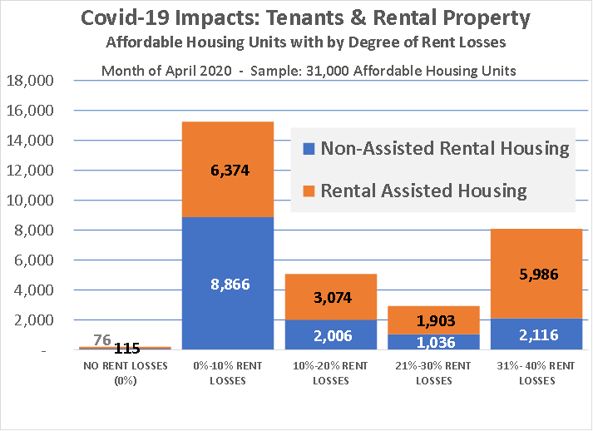

### The table above shows the concentrations of rent losses either under 10% rent loss (modest) or between 31% to 40% rent losses (extremely high). The table below includes a summary of the raw data.

[](http://gmhf.com/)