Homeschool Grade School Art (Group) 2024-2025
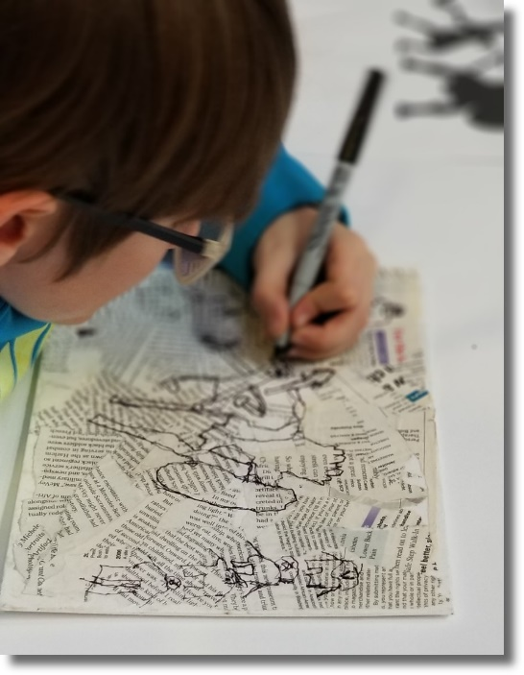
This is a class which helps build the fundamental art skills of students 7 - 12 years of age. All grade school students are given the opportunity to participate in a number of art projects throughout the semester. These projects may consist of drawing, painting, printing, sculpting, engraving, or more. Our large assortment of fine art media allows us the luxury of tailoring projects to fit the learning styles of each student. All students are encouraged to produce work for our end of semester art show. No previous art experience is necessary for this class.
Meets Tuesdays from 2:00 - 3:00 p.m. (*all materials included)
Fall Semester Cost: $195 / semester @ 1 hr. per wk. for 14 sessions ($185 on or before Saturday, June 15th, 2024)

Full Year Cost: $370 / academic year @ 1 hr. per wk. for 28 sessions ($360 on or before Saturday, June 15th, 2024)

Fall semester begins: Tuesday, August 27th and runs through Tuesday, December 10th, 2024
Spring semester begins: Tuesday, February 4th, and runs through Tuesday, May 13th, 2025

Recommended Ages: 7 - 12

