Grade School Ages 10-12 Intermediate (Group) Fall 2021
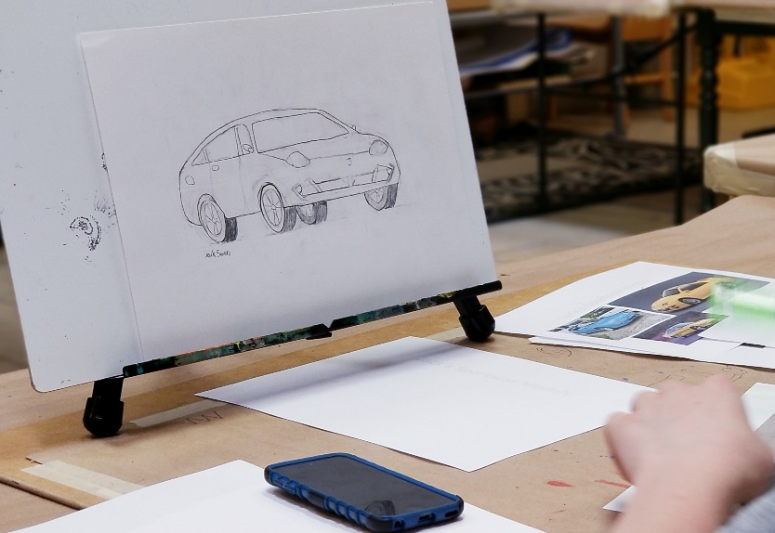
This class is most suitable for students who’ve had some exposure to fundamental fine art concepts. Students in this class will be given the opportunity to participate in a number of art projects throughout the semester ranging from drawing and painting, to printing and sculpting. Our large assortment of fine art media allows us the luxury of tailoring projects to fit the learning styles of each student. All students are encouraged to produce work for our end of semester art show.
$250 / semester @ 1 hr. per wk. for 18 weeks ($230 before Friday, December 18th, 2020)
$325 / semester @ 1.5 hrs. per wk. for 18 weeks ($310 before Friday, December 18th, 2020)
(*all materials included)
Meets Thursdays from 4:00 - 5:00 p.m. or 4:00 - 5:30 p.m. Begins Thursday, August 5th and runs through Thursday, December 16th, 2021.
Ages: 10 - 12 (recommended)

