Homeschool High School Group) 2026-2027
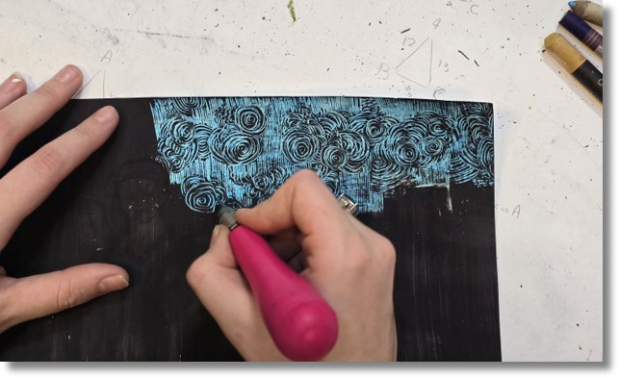
This class is for students displaying intermediate artistic skills in theme-based projects and have had some experience with three-dimensional drawing, perspective, and color theory. High School students in this class are presented with more challenging material in addition to given the opportunity to participate in theme and community-based projects. Students will enjoy engaging in fun, "right brain" activities all while receiving 21 hours of fine art instruction! All are encouraged to produce work for our end of semester art show.
Meets Thursdays from 2:00 - 3:30 p.m. (*all materials included)
Semester Cost: $336 / semester @ 1.5 hrs. per wk. for 14 sessions ($321 on or before Saturday, August 1st, 2026)

Full Year Cost: $657 / academic year @ 1.5 hrs. per wk. for 28 sessions ($635 on or before Saturday, August 1st, 2026)
Fall semester begins: Thursday, August 20th and runs through Thursday, December 3rd, 2026

Spring semester begins: Thursday, January 28th and runs through Thursday, May 6th, 2027

Recommended Ages: 13 - 18

