CLAY PROJECTS W/JANICE
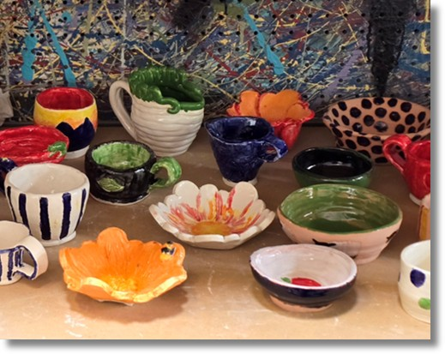
In this 8-week session, you will learn the foundations of pottery and hand-building using earth clay. Create fun projects with slabs, coils and a variety of cool glazing techniques!
Meets MONDAYS from 1:30 pm – 3:00 pm
Begins Monday, September 14th and runs through Monday, November 2nd, 2026
Cost: $312
*ALL MATERIALS INCLUDED
Recommended Ages: 18 & up


Janice lives in Johnson City and recently retired after 25 years of teaching Pre-K through 8th grade. She received her BFA from ETSU where she acquired her certification for teaching art grades 1-12. She also received an elementary art certification from Milligan University. To her, teaching art has its advantages because it allows her to enjoy a variety of media as well as art history. She is especially fond of pottery, and at various times, enjoys hand building and throwing on the wheel. In her spare time she likes to read, and play cards and board games with her family—especially the grandkids!

