Private Classes
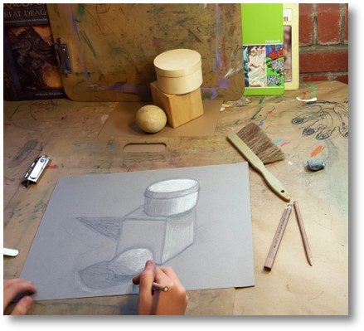
Private classes at MOMAC Studio are designed to channel a student's special interest, emphasize strengths, and encourage areas and methods of fine art unexplored. Working toward specific portfolio goals is also encouraged and welcomed in the private lesson format. The number of weeks a student chooses to enroll in would be based on what he or she would like to learn to ensure that the time allotted would fit his or her needs appropriately. The potential for a student's artwork to be displayed publicly and the number of networking opportunities is more prevalent in a private art class. Private lessons are also a great way to build a portfolio that satisfies submission requirements for those looking to attend college art programs.
We also encourage our private lesson students to participate in the many community art projects that we are a part of here at MOMAC studio. (Please refer to our website for viewing instructor portfolios - http://www.momacstudio.com/the-momac-team-gallery/)
5 one-hour classes - $175
10 one-hour classes - $340
15 one-hour classes - $495
*Other options including the number of hours and rates are available upon request. All materials are included.
Class scheduling is arranged on an individual basis with the instructor.
Please email: momacstudio101@gmail.com

