Jr. High / High School Art (Group) Fall 2022
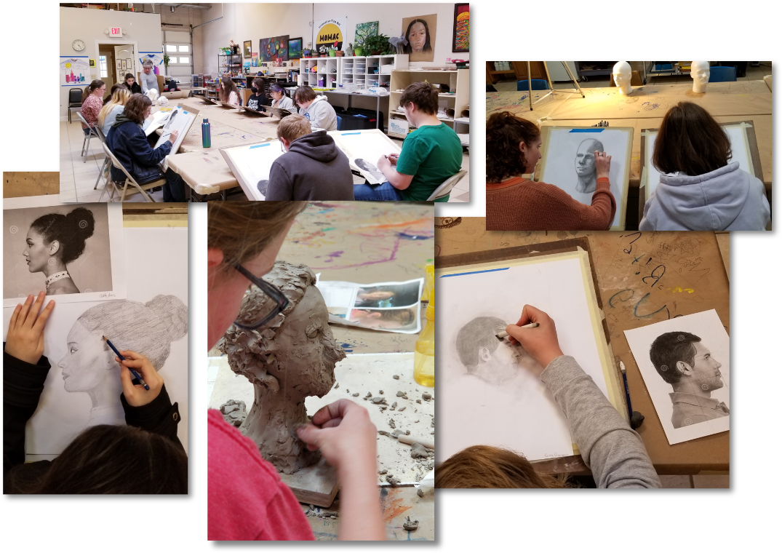
This class is for students displaying intermediate skills in theme-based projects. It is designed for those who enjoy the creative energy of the art studio and the camaraderie that exists between other young artists. Most (but not all) students in this class will have a basic knowledge of fine art concepts and exposure to various art methods and techniques. Students in this class will also have the luxury of working at their own pace while at the same time be challenged with new material as the instructor sees fit. All are encouraged to produce work for our end of semester art show.
$250 / 18-week semester @ 1 hr. per wk. for 18 sessions ($235 on or before Saturday, July 2nd, 2022)
$325 / 18-week semester @ 1.5 hrs. per week for 18 sessions ($310 on or before Saturday, July 2nd, 2022)
(*all materials included)
Meets Fridays from 4:00-5:00 p.m. or 4:00 - 5:30 p.m. Begins Friday, August 5th, and runs through Friday, December 16th, 2022)
Ages 13 -18

