Grade School Ages 7-9 (Group) Spring 2022
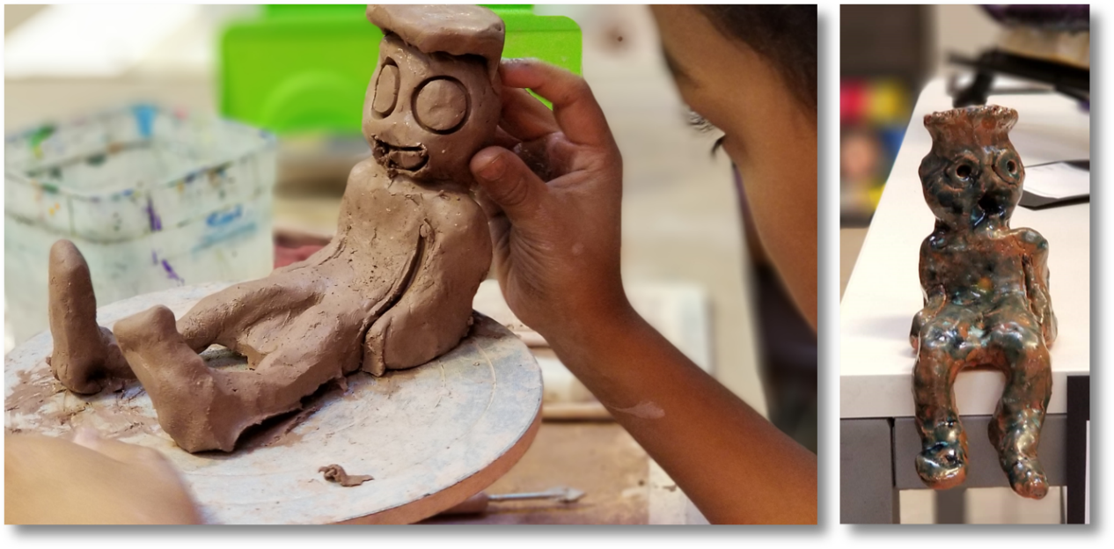
This is a class which helps build the fundamental art skills of students 7 - 9 years of age. All grade school students are given the opportunity to participate in a number of art projects throughout the semester. These projects may consist of drawing, painting, printing, sculpting, engraving, or more. Our large assortment of fine art media allows us the luxury of tailoring projects to fit the learning styles of each student. All students are encouraged to produce work for our end of semester. No previous art experience is necessary for this class.
Cost: $250 / semester @ 1 hr. per wk. for 18 sessions ($235 on or before Tuesday November 20th, 2021)
(*all materials included)
Meets Tuesdays & Wednesdays from 4:00 - 5:00 p.m. or 4:00 - 5:30 p.m. Begins Tuesday, January 11th & Wednesday, January 12th and runs through Tuesday, May 24th and Wednesday May 18th, 2022
Ages: 7 - 9

