SCULPTING BASICS W/LADONNA
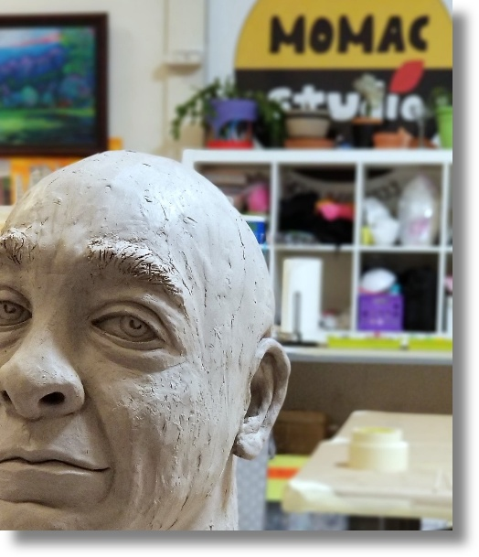
In this 12-hour semi-private course LaDonna will gently guide you through fundamental sculpting techniques in a variety of exciting sculpting media including clay, wire, and paper. Hone your skills and create an art piece you that you will be pleased to display!
Meets every Thursday from 10 am – 12noon & 6 – 8 pm
Session 1 begins: Thursday, August 6th and runs through Thursday, September 10th, 2026
Session 2 begins: Thursday, September 17th and runs through Thursday, October 29th, 2026
Cost: $675
*ALL MATERIALS INCLUDED
Recommended Ages: 18 & up

