Homeschool Grade School Art (Group) Spring 2022
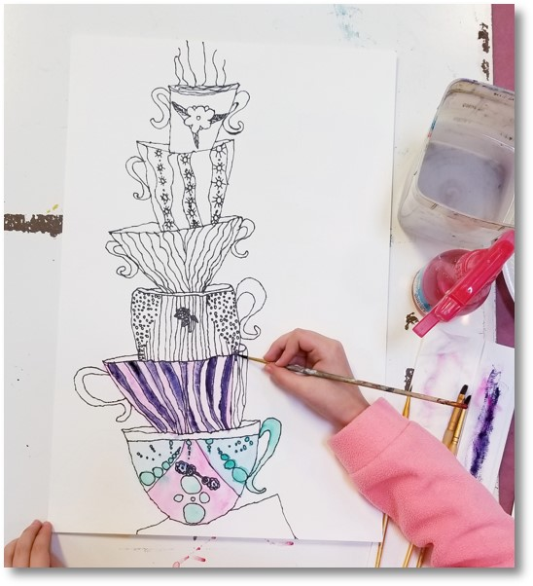
This is a class which helps build the fundamental art skills of students 7 - 12 years of age. All grade school students are given the opportunity to participate in number of art projects throughout the semester. These projects may consist of drawing, painting, printing, sculpting, engraving, or more. Our large assortment of fine art media allows us the luxury of tailoring projects to fit the learning styles of each student. All students are encouraged to produce work for our end of semester art show. No previous art experience is necessary for this class.
$195 / semester @ 1 hr. per wk. for 14 weeks ($185 before Tuesday, November 30th, 2021)
(*all materials included)
*We offer discounts for siblings. Please call: (423) 366-2533 and ask for the discount code when registering.
Meets Tuesdays from 2:00 - 3:00 beginning Tuesday, February 1st and runs through Tuesday, May 10th, 2022.
Ages: 7 - 12

