DRAWING BASICS W/LADONNA
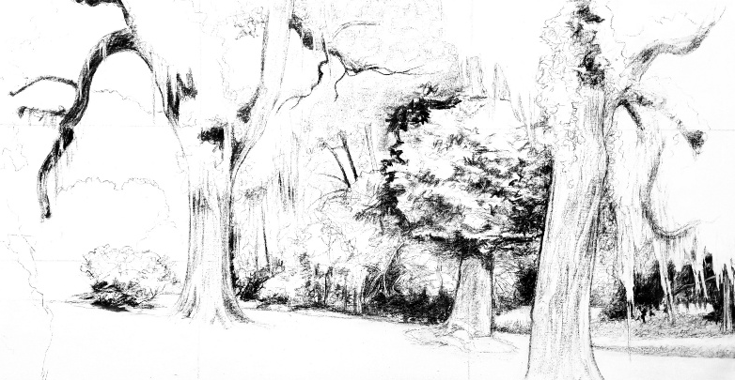

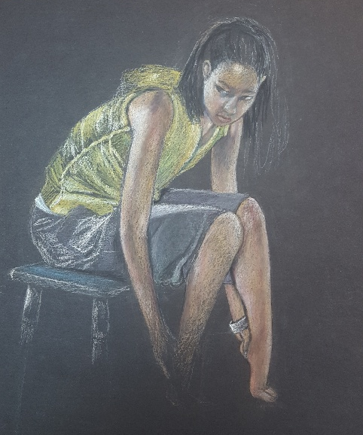
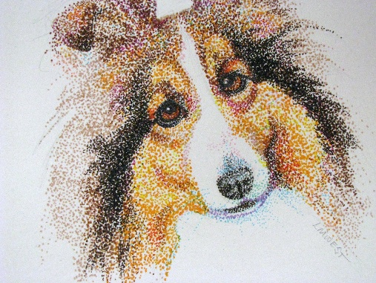

This 12-hr. drawing intensive covers techniques in a variety of dry media including graphite, charcoal, pen & ink, pastel, & colored pencils. Learn the properties of the media used and how to combine them masterfully!
Meets every Tuesday, from 5:30-7:30 pm OR every Friday from 10 am – 12noon
Begins Tuesday, August 11th & Friday, August 14th and runs through Tuesday, September 15th & Friday, September 18th, 2026
Cost: $585
*ALL MATERIALS INCLUDED
Recommended Ages: 18 & up

