Beginner Wheel Throwing & Hand Building w/Mrs. Flynn
Mondays, 4:00-5:30pm, beginning January 19th through March 30th, 2026

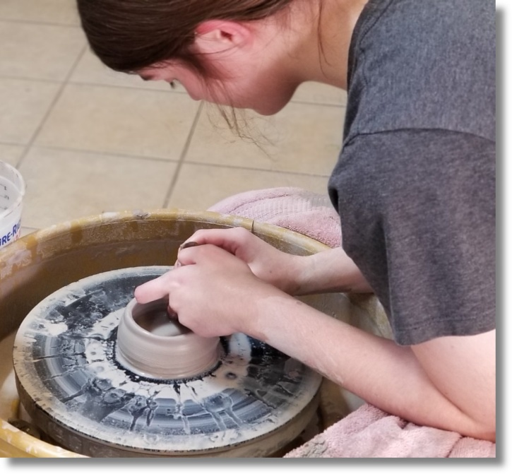

Students in this 10-week course will learn the essence of pinch pot, coil, and slab building with clay as well as exploring textures and glazing. On the wheel, they will learn how to center, open, and pull clay to form shapes. They will also learn how to trim, add handles, and glaze to bring a beautiful finish to their clay pieces!
$285/student
*All materials are provided in this course.
Age group – High School through Adult


Janice lives in Johnson City and recently retired after 25 years of teaching Pre-K through 8th grade. She received her BFA from ETSU where she acquired her certification for teaching art grades 1-12. She also received an elementary art certification from Milligan University. To her, teaching art has its advantages because it allows her to enjoy a variety of media as well as art history. She is especially fond of pottery, and at various times, enjoys hand building and throwing on the wheel. In her spare time she likes to read, and play cards and board games with her family—especially the grandkids!

