CLAY PROJECTS W/JANICE
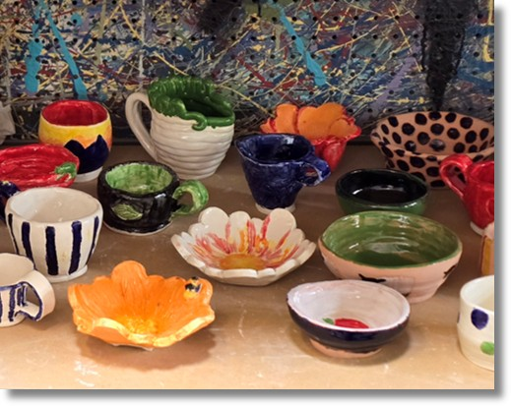
Learn the foundations of pottery and hand-building using earth clay. Create fun projects with slabs, coils and a variety of cool glazing techniques!
Meets MONDAYS from 1:30 am – 3:00 pm
Begins Monday, August 31st and runs through Monday, December 7th, 2026
Cost: $315
*ALL MATERIALS INCLUDED
Recommended Ages: 18 & up

