Beginner Drawing Course w/Mrs. Flynn
Wednesdays, 10:30-11:30am, beginning August 27th through October 22nd, 2025
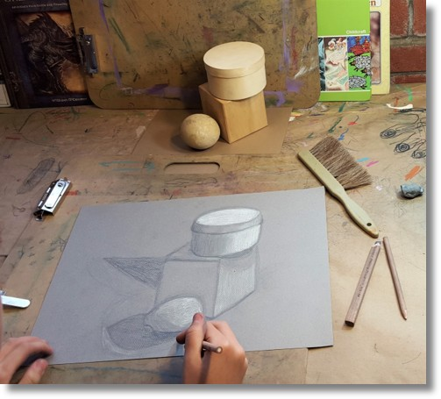
This 9-week beginner course is designed for those wanting to improve and practice their drawing skills. It will include techniques in contour drawing, three-dimensional shading, and studies in landscapes, portraits and proportion, realism and style, and perspective. The art media will include pen, pencil, pastels, and conte crayons. This class is ideal for adults who are looking to sharpen their drawing skills as well as for homeschool high school students who need a fine art elective!
$165/student
*All materials are provided in this course.
Age group – Adults and high schoolers


Janice lives in Johnson City and recently retired after 25 years of teaching Pre-K through 8th grade. She received her BFA from ETSU where she acquired her certification for teaching art grades 1-12. She also received an elementary art certification from Milligan University. To her, teaching art has its advantages because it allows her to enjoy a variety of media as well as art history. She is especially fond of pottery, and at various times, enjoys hand building and throwing on the wheel. In her spare time she likes to read, and play cards and board games with her family—especially the grandkids!

