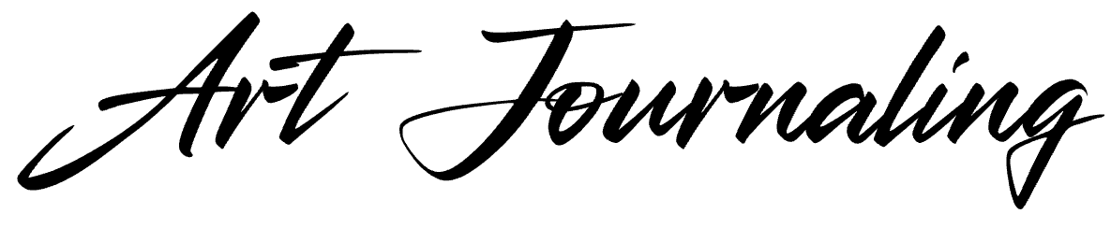

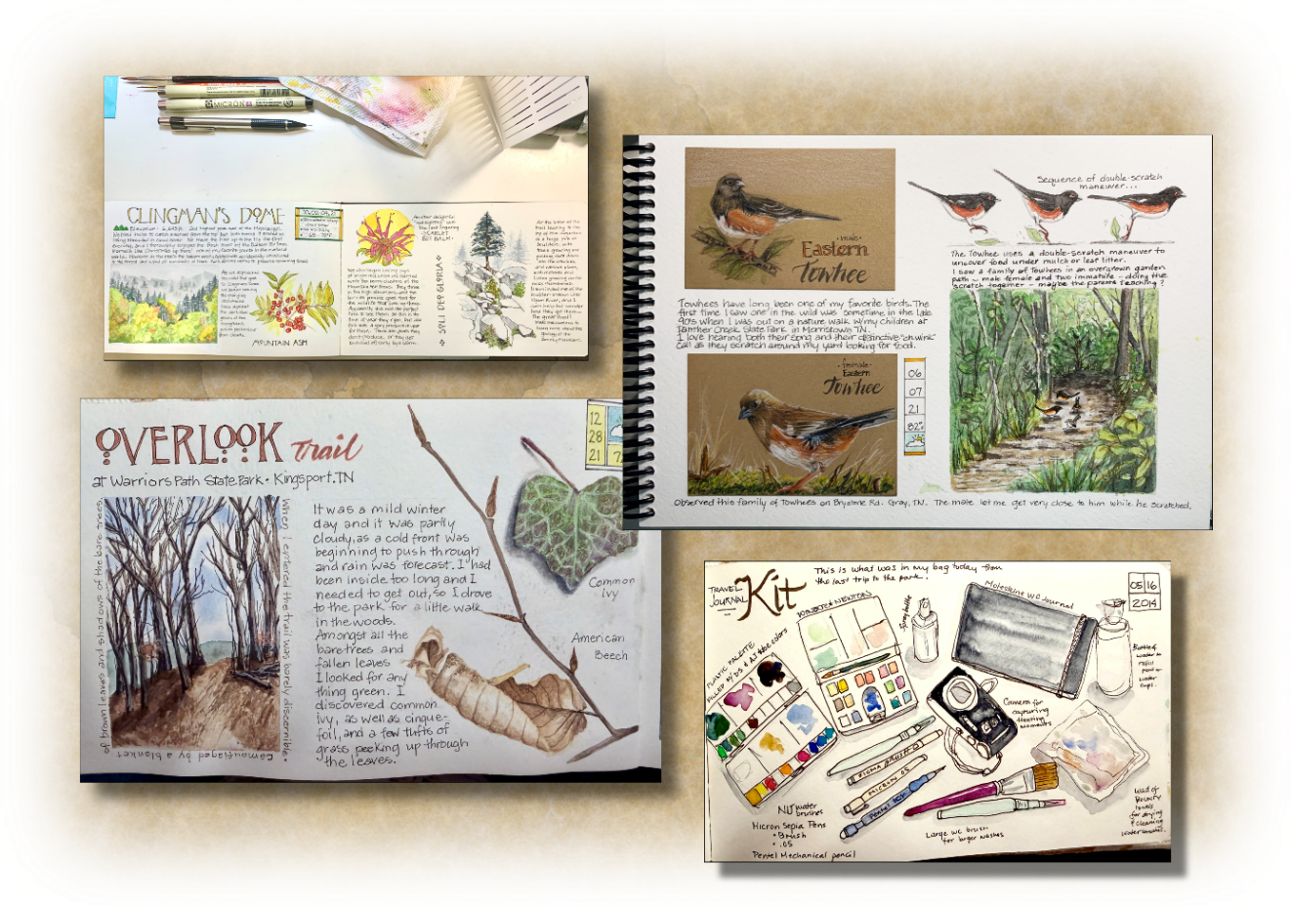
w/Rosanne Haaland

Enjoy this exciting 10-week, 15hr. course with stellar and local artist, Rosanne Haaland as you discover the world of art journaling! No worries if you’ve never had any drawing or painting experience because Rosanne will gently guide you through that! Learn journal page concepts, lettering for journals, beginning watercolor sketching, ink drawing, collage, watercolor pencils, on-site sketching, etc., as well as a little bit of the history of sketchbooks!
Meets WEDNESDAYS from 10:00 am – 11:30 am
Begins Wednesday, September 2nd and run through Wednesday, November 4th, 2026
Cost: $390
Recommended Ages: 18 & up

Rosanne Haaland is a retired art teacher who still teaches, but in different settings than the school classroom. She currently leads a nature journaling club for homeschoolers, and has led workshops for adults in nature journaling in various venues. Art journaling of various types has been a passion for a long time, and she loves to encourage others to try it too.
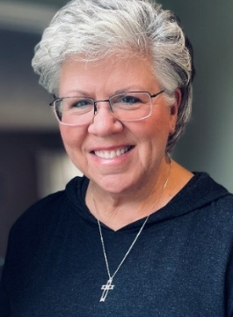
Rosanne lives in Gray with her artist/engineer husband, Rod.

