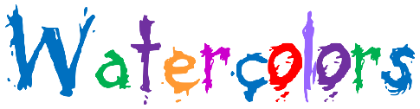
The Healing Nature of

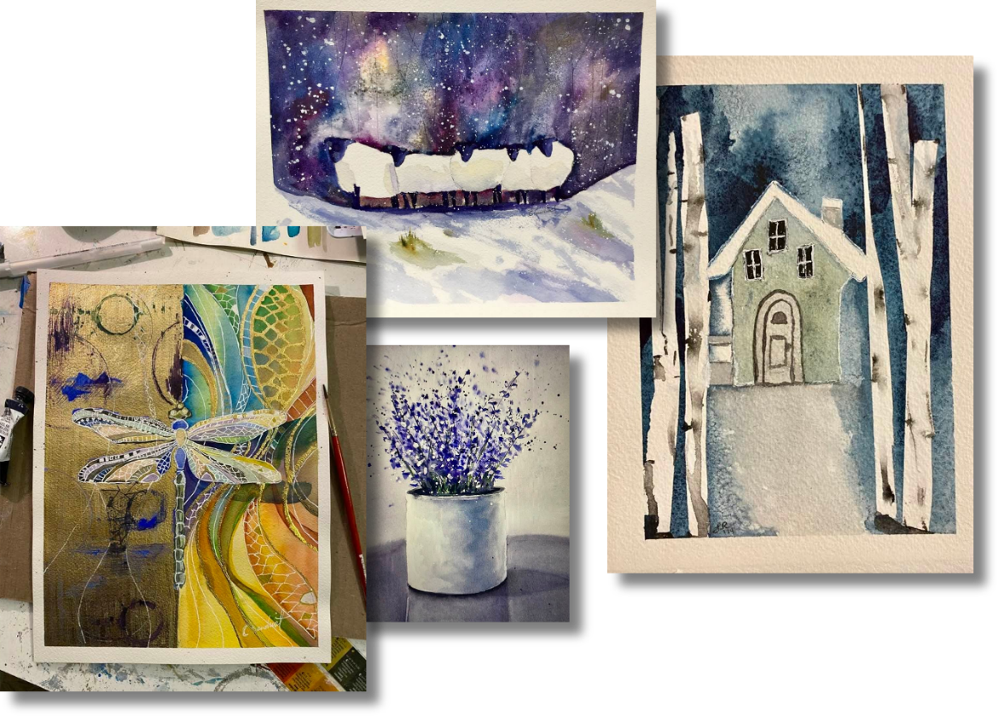
w/Corrine Baudinot

Join Corrine in this 8-week watercolor course and develop both skill and self-expression through the tools she teaches you to use!
Meets FRIDAYS from 2:00 pm – 3:30 pm
Begins Friday, September 4th and run through Friday, October 23rd, 2026
Cost: $312
Recommended Ages: 18 & up
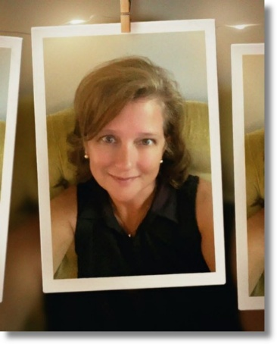
I am a watercolor artist drawn to the quiet beauty of everyday moments. I love how the paint and water flow together unpredictably, teaching to let go and experience the process. Painting has been a deeply, personal journey for me. I didn’t follow a traditional path. My studies were in photography and communication, but after an accident that kept me immobile for a time, I discovered the healing nature of painting. I continued my education in fine art at ETSU and have taken many classes and workshops. I look forward to sharing the way I have learned to express art with you. My expectation for you is that you develop a passion for life and cultivate both skill and self-expression through the tools I teach you to use. I have 5 children and live in Johnson City.

