Homeschool High School Group) 2024-2025
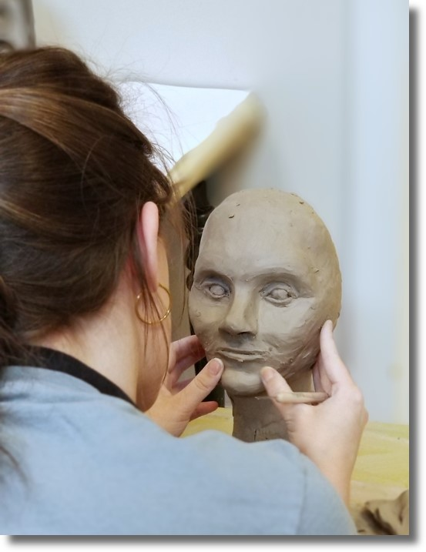
This class is for students displaying intermediate artistic skills in theme-based projects and have had some experience with three-dimensional drawing, perspective, and color theory. High School students in this class are presented with more challenging material in addition to given the opportunity to participate in theme and community-based projects. Students will enjoy engaging in fun, "right brain" activities all while receiving 21 hours of fine art instruction! All are encouraged to produce work for our end of semester art show.
Meets Thursdays from 2:00 - 3:30 p.m. (*all materials included)
Fall Semester Cost: $275 / semester @ 1.5 hrs. per wk. for 14 sessions ($265 on or before Saturday, June 15th, 2024)

Full Year Cost: $530 / academic year @ 1.5 hrs. per wk. for 28 sessions ($520 on or before Saturday, June 15th, 2024)
Fall semester begins: Thursday, August 29th and runs through Thursday, December 12th, 2024

Spring semester begins: Thursday, January 30th and runs through Thursday, May 8th, 2025

Recommended Ages: 13 - 18

