Homeschool High School Art (Group) Fall 2022
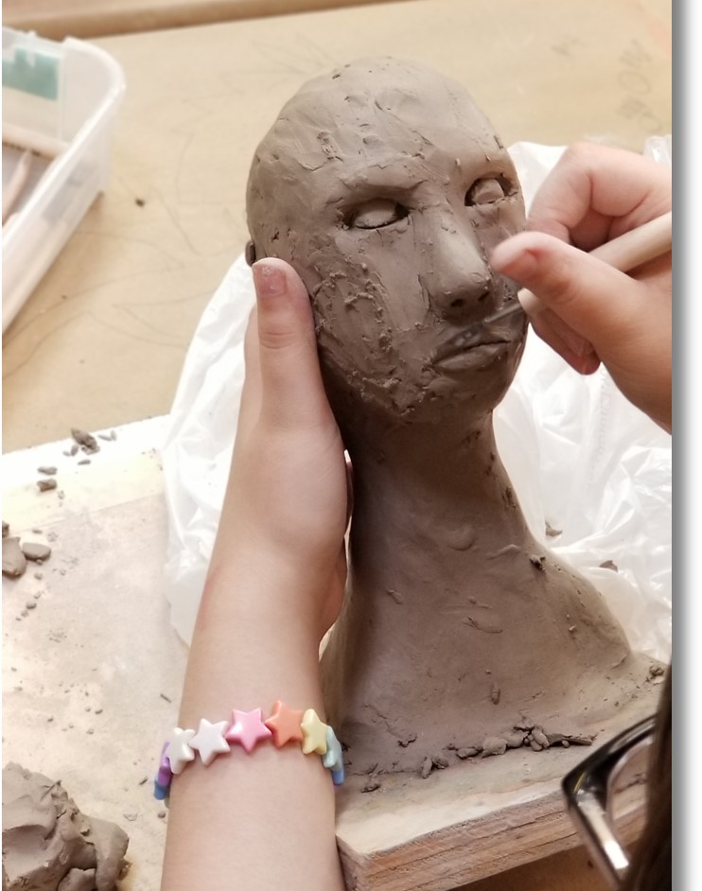
This class is for students displaying intermediate artistic skills in theme-based projects and have had some experience with three-dimensional drawing, perspective, and color theory. High School students in this class are presented with more challenging material in addition to given the opportunity to participate in theme and community-based projects. Students will enjoy engaging in fun, "right brain" activities all while receiving 21 hours of fine art instruction! All are encouraged to produce work for our end of semester art show.
$275 / 14-week semester @ 1.5 hrs. per wk. ($265 before Saturday July 2nd, 2022)
(*all materials included)
*We offer discounts for siblings. Please call: (423) 366-2533 and ask for discount the code when registering.
Meets Thursdays from 2:00 - 3:30. Begins Thursday, August 25th, and runs through Thursday, December 8th, 2022.
Recommended Ages: 13 - 18

