MAC-Time! Grade School Art
Recommended Ages 8-10 (Group) Spring 2022

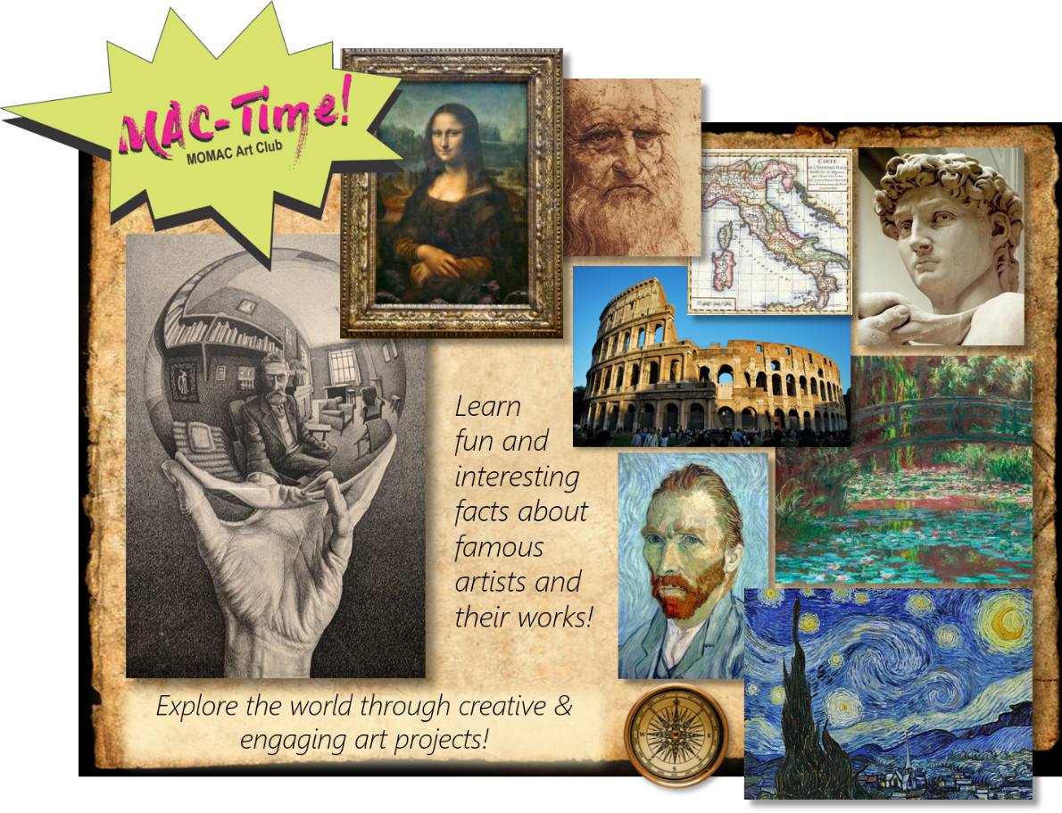

In this exciting new class, students will enjoy learning about and creating art based on works by famous artists throughout time! They will engage in fun facts, art-related Q&A and be immersed in an array of projects which are sure to make a lasting impression in the years to come. Lessons are conducted in a way which will encourage creativity, build confidence and promote a sense of accomplishment.
Cost: $250 / semester @ 1.5 hr. per wk. for 12 sessions ($235 on or before Tuesday November 20th, 2021)
(*all materials included)
Meets Wednesdays from 4:00 - 5:30 p.m. Begins Wednesday, January 26th and runs through Wednesday, April 20th, 2022
Recommended Ages: 8 - 10

