MOMAC Jr. Studio K4-6 (Group) Fall 2022
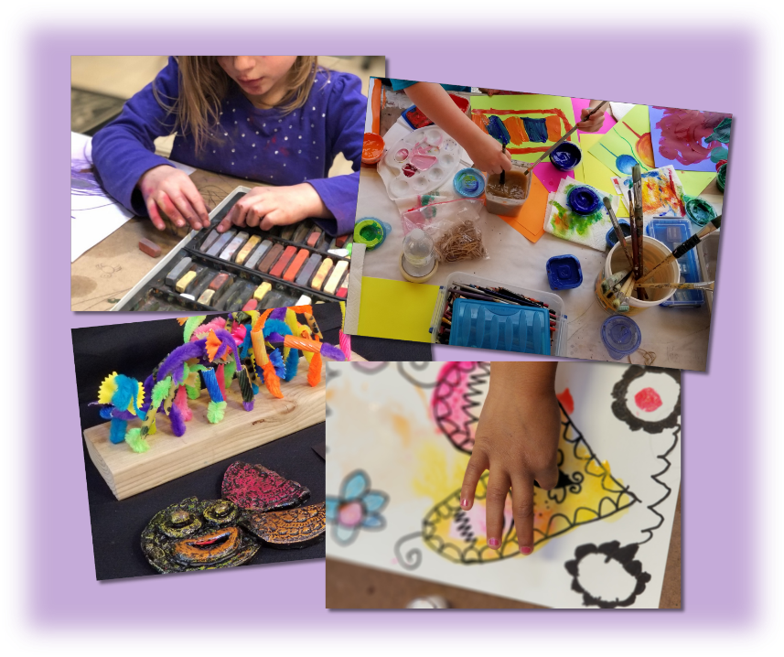
MOMAC Jr. Studio students will build foundational skills that they not only can use in art but can employ for a lifetime. They, like all MOMAC students, will work toward our end of semester art show!
Cost: $150 / 12 sessions @ 1 hr. per wk. (first come/first serve)
(*all materials included)
Meets Mondays 4:30 - 5:30 p.m. Begins Monday, September 12th, and runs through Monday, December 5th, 2022 (Make-up days are arranged between the student and teacher).
Ages: 4 - 6

