EXPLORING ELEMENTS OF ART IN DRAWING, PAINTING & CLAY
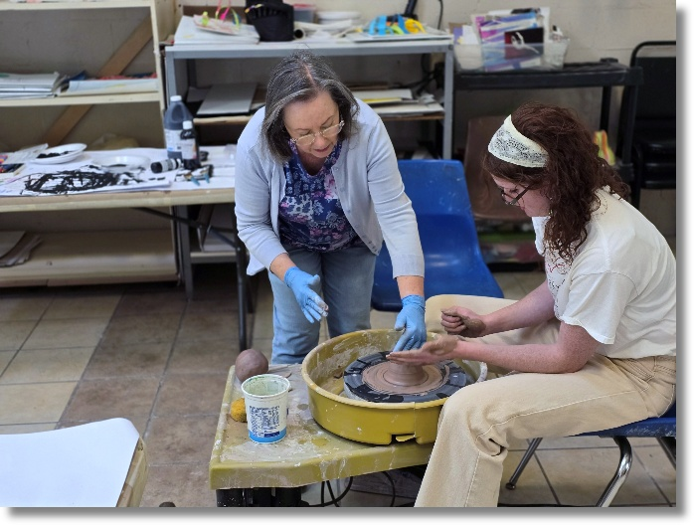
Learn how to apply the foundational principles of art in drawing, painting & clay in this 14-week art course intensive! *ALL MATERIALS INCLUDED
Meets MONDAYS from 1:30 am – 3:00 pm
Begins Monday, August 31st and runs through Monday, December 7th, 2026
Cost: $315
*ALL MATERIALS INCLUDED
Recommended Ages: 18 & up

