MOMAC Jr. Studio K4-6 (Group) Fall 2021
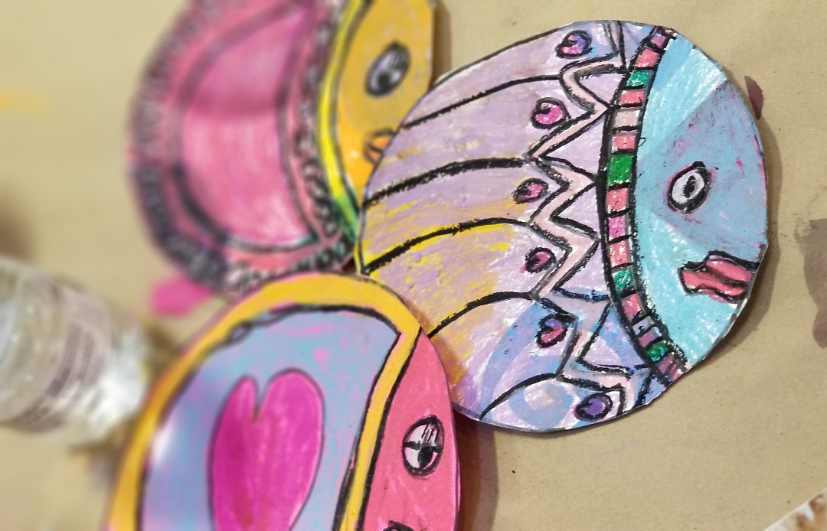
MOMAC Jr. Studio students will build foundational skills that they not only can use in art but can employ for a lifetime. They, like all MOMAC students, will work toward our end of semester art show!
$150 / 18-week semester @ 1 hr. per wk. for 18 weeks (first come/first serve)
(*all materials included)
Meets Mondays 4:30 - 5:30 p.m. Begins Monday, August 9th and runs through Monday, December 13th (Make-up days are arranged between the student and teacher).
Ages: 4 - 6

