PORTFOLIO DEVELOPMENT W/LADONNA
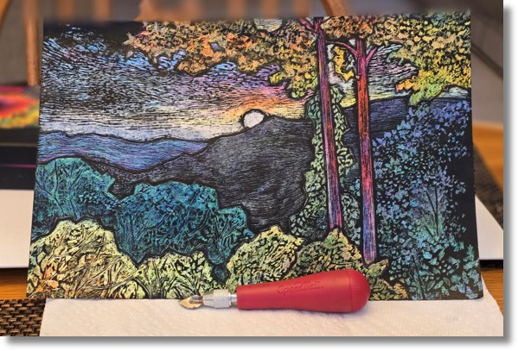
This class is for intermediate to advanced students looking to build a strong portfolio for college and/or a career in fine art. It includes working in all visual art media and covers a vast array of elements needed to meet standard portfolio requirements (some of which include but are not limited to:
- How to render work which displays an understanding of basic drawing & illustration principles
- How to handle a wide range of fine art media
- Concepts of photography and digital media
- 3D rendering in sculpture (which can include clay, ceramics, & mixed media)
This is also a semi-private class where students gain access to professional environments and can network with the professional community (including opportunities to sell their artwork).
SATURDAYS from 10:00 am - 1 pm
Begins: Saturday September 5th and runs through Saturday December 5th, 2026
Cost: $1,250/Semester/36 hrs.
*ALL MATERIALS INCLUDED
Recommended Ages: 18 & up

