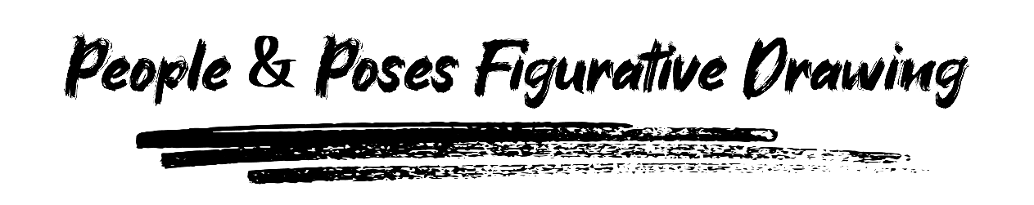

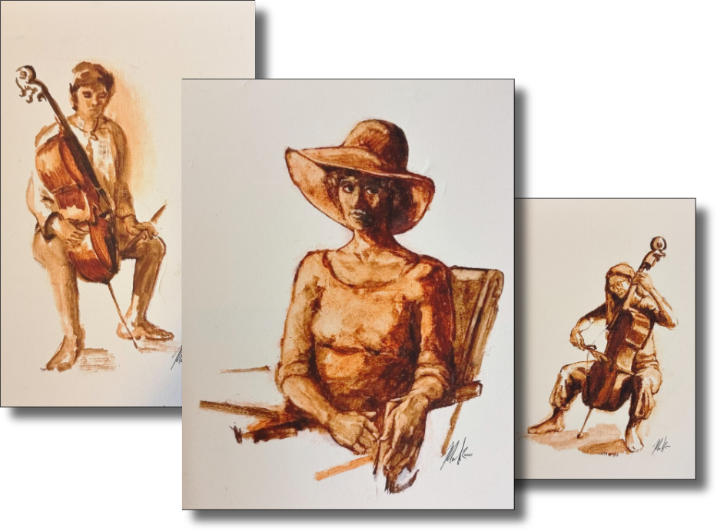

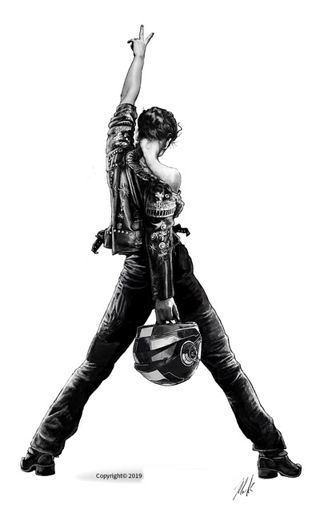

Want to level up your figure drawing? This course for beginning, medium and advanced artists will help you to learn, expand and polish your rendering skills of live models from basic gestural renderings & shading to more advanced techniques of line quality, layout & lighting composition. Build a foundation for personal & live explorations in pencil, graphite & pastels for everyday figurative sketching!
Meets THURSDAYS from 6:00 pm – 8:00 pm
Begins Friday, September 3rd and runs through Thursday, October 22nd, 2026
Cost: $416
Recommended Ages: 18 & up
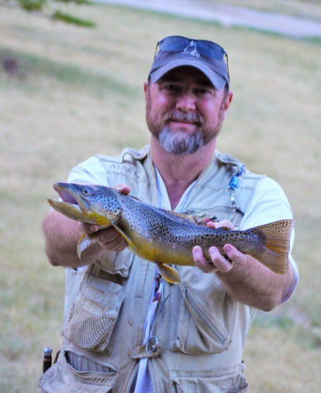
Mark Anderson grew up in Johnson City, attending University High School and graduating from ETSU. He has worked as an art director & creative director at a full-service advertising agency, director of marketing for a large apparel manufacturer and 26 years as a full-time freelance graphic designer and illustrator. Comfortable and proficient with digital media, Mark works on a Mac and XP-Pen digital tablet with the Adobe Suite of applications. He does traditional hand renderings in pencil, pastels, pen & ink, oils and watercolors, as well as bronze sculpture. Recently retired, Mark looks to continue his artistic journey by reconnecting to his classic rendering roots and is looking forward to passing on his experience as a mentor and teacher. He is devoted to his two grown kids and enjoys fly fishing and photography.

