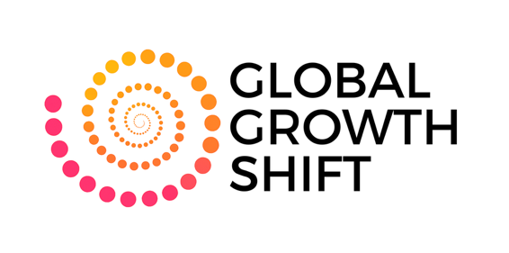
The Art of Making Allies and Believers
PARTICIPANT WORKSHEET
Your Leadership Network Map and Action Plan

Presenter: Nancy G. Allen, Global Growth Shift

1. Identify your allies
List 3–5 people who actively support your work, advocate for you, or provide access.

2. Identify your believers
List 2–3 people who see potential in you that you may not yet see in yourself.

3. Anchors and engines reflection

A. Engines — the people who push you forward

B. Anchors — the people who keep you where you are

4. Leadership action plan
Who is a priority relationship you will commit to strengthen this month? Name the person and why this relationship matters:

A. Five ways to cultivate an ally, believer or engine

1. Express appreciation
One appreciation message you will send this week:

2. Share your goals
One goal you will share with this person:

3. Make a clear ask
What specific support or feedback you need:

4. Offer value back
A resource, introduction, or act of support you can offer:

5. Stay consistent
One small way you will stay connected regularly:

B. Boundary to set with an anchor
What is a boundary or shift you will implement this month? Name the person and why this relationship matters:

C. 30-Day leadership commitment
Over the next 30 days, I commit to cultivating relationships that help me grow as a leader by…

For more information, contact Nancy G. Allen, President and CEO of the Global Growth Shift at the WBDC of Florida, nancyallen@womensbusiness.info

Global Growth Shift empowers women business leaders worldwide to grow, lead, and access new markets. Through training, connections, and global opportunities, we help women expand their impact, build sustainable companies, and join a supportive community transforming business around the world.

Reach out on LinkedIn to our Global Growth Shift team:
Nancy Allen, https://www.linkedin.com/in/nancygallen/
Diane Sears, https://www.linkedin.com/in/dianemariesears/

