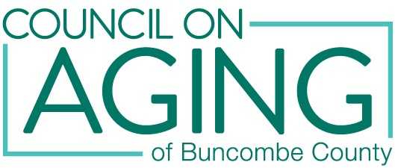
Update on Senior Dining Program
Lakeview Community Center and Weaverville First Baptist Church will open for congregate dining on Monday, August 2, 2021. Senior Opportunity Center will open for congregate dining on Tuesday, September 7, 2021. These three sites will provide meals five days a week, Monday - Friday. We will still offer curbside pickup of meals and limited delivery of meals. The limited delivery of meals will only be for those people who are homebound and physically unable to use Mountain Mobility. The Senior Dining Program is funded by the Home and Community Care Block Grant (HCCBG) to provide congregate nutrition as well as socialization. This hybrid model of congregate dining, curbside pick of meals, and delivery of meals will be evaluated on a month to month basis.
Shiloh Community Center will open for congregate dining on Wednesday, August 18, 2021, for three days a week, Wednesday - Friday. We will still offer curbside pickup of meals.
Menus - Milk
The menus for the Senior Dining Program must be approved by a registered dietitian nutritionist (RDN) and each meal must meet 33% of the recommended daily allowance (RDA) for older adults. One of the key targets to meet the RDA is 400 mg of calcium per meal. The meals come with skim milk in order to meet this dietary requirement. Starting in August, all participants must take the skim milk offered with the meal. The senior dining sites are not allowed to store any food in their refrigerators as all food served at the meal sites must be eaten that day as required by the HCCBG.
Questions or Concerns
Any questions or concerns may be directed to Billie Breeden, Director of Congregate Nutrition, at 828-277-8288.

