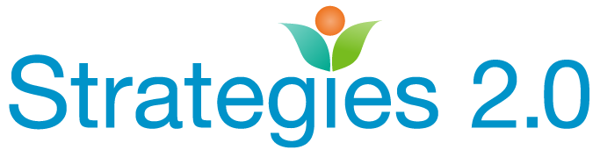

We provide an integrated learning system that includes
TRAINING, CONSULTATION, and NETWORKING for the family strengthening field.

REGISTRATION IS OPEN!
Sierra Region Learning Community Convening

Topic: Bringing Us Together: Using the ACES Connection On-line Platform to Support Efficient Collaboration Across Sectors and Communities

To enroll in this event visit: strategiesca.org

When: Thursday, June 14, 2018
Where: In person at the Amador Child Abuse Prevention Council in Jackson, on-line at your computer, and remote sites in Markleville and Loyalton (Loyalton site to be confirmed).
Time: 10:00 a.m. – 2:30 p.m. Registration begins at 9:30 a.m.

Featuring: Gail Kennedy from ACES Connection and Tracy Fauver from Yolo County CASA. Network with your peers in the Sierra Nevada Region and learn about the ACES Connection website, a powerful tool for collaboration. Take a tour of the site, and explore the potential for ACES Connection to create a movement in your community to “prevent trauma, heal ACES and build resilience”. Bring your laptop or mobile device for hands on experience with the many features of the ACES Connection website! Prior to the Learning Community, take a moment to visit the website at: http://www.acesconnection.com/

To ensure you receive email updates, sign up to receive the Strategies2.0 newsletter by visiting: Strategies2.0

