GRASP Newsletter
  - Fall Edition
Senior Program
GRASP has introduced a senior program specifically for individuals 60 and above. This program was developed because we saw a need in this population that is often overlooked. GRASP noticed that older adults living together were being disqualified from services because of their income level. We realize that depression is a serious issue for older adults and that the need for social interaction and companionship is paramount. If you know an older adult who is in need of food, utility or prescription assistance, please call our office!
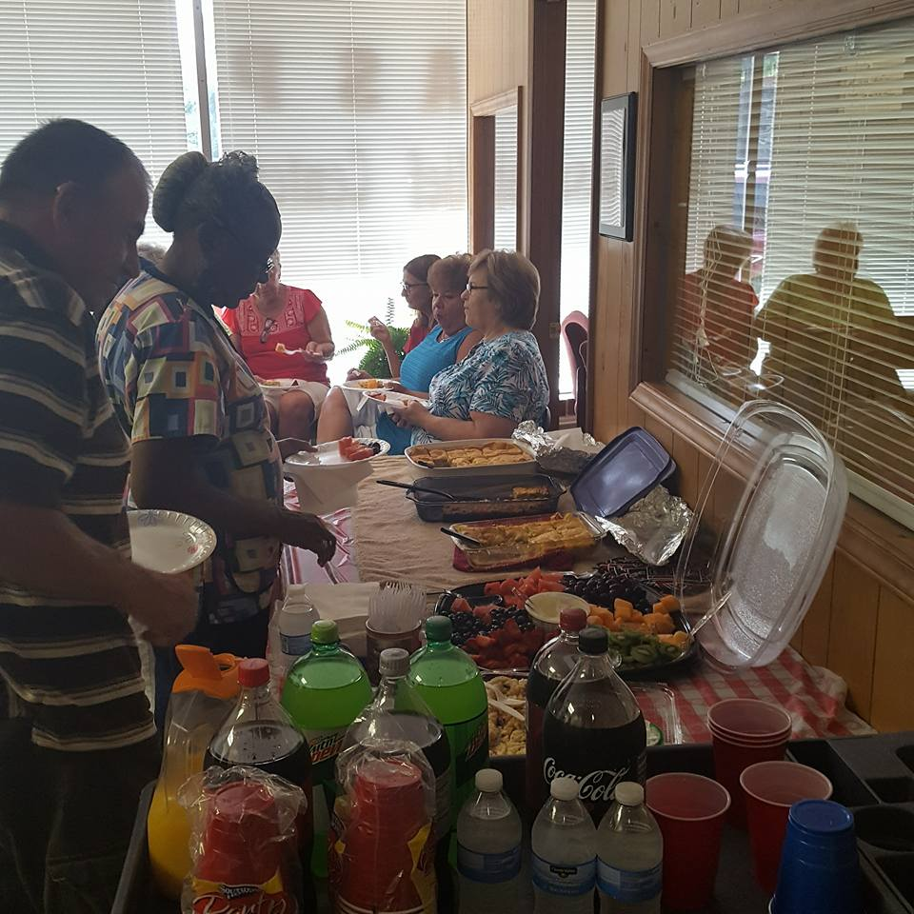
Some of our dedicated volunteers participating in a training session.

Thrift Shop Coming Soon!
GRASP has decided to embark on a new business endeavor of opening a thrift shop here in Great Falls. We plan to utilize the profit from this business to support our programs at GRASP. Our board has a vision of a store in town which provides a place for people to donate clothes and household items with the knowledge that they will be directly benefiting their own community. This store will allow people to purchase gently used necessities at a deeply discounted price.
Thank you to everyone who has donated funds to help us purchase a building for our thrift shop. We sincerely appreciate your support and we still need help! If you think this would be a great benefit to our community, please donate today.

Upcoming Events
GRASP Food Drives: October 9th-November 29th (Boxes located at IGA in Great Falls and Richburg, Spratt Savings & Loan, Sassy Scissors Salon)
#Giving Tuesday: November 28, 2017-be a part of the movement to help our organization meet our year end fundraising goals
Christmas in the Falls: December 9th: GRASP will have a booth in front of our office. Please come out and support us and our town during this celebration!
Meet GRASP’S Newly Appointed Honorary Lifetime Board Member
We are proud to announce that Mrs. Dollie Roberts has been appointed an Honorary Lifetime Board Member of GRASP because of her many years of work and dedication. Dollie has served on our board, worked as a volunteer and contributed countless hours of time advocating for GRASP in our community. We are so happy that Dollie has chosen to share her wealth of knowledge and experience with us as we continue to serve the individuals and families in our community who need it most.
Our deepest condolences go out to the family of Ephraim Jackson who dedicated so much of his life to GRASP.

collaborations
In our quest to find a way to get the resources our clients need to find a way out of poverty we have initiated some collaborations with other agencies. We will be working with SC Works to have a representative come to the GRASP office to meet with clients who are trying to locate employment or gain job training skills. SC Works provides a wealth of resources such as education, skill building, on the job training and interviewing techniques. GRASP will also partner with WelVista to provide a resource to our clients and community members who do not have health insurance. This program will provide prescriptions at no out of pocket cost to clients.

We Need you!!
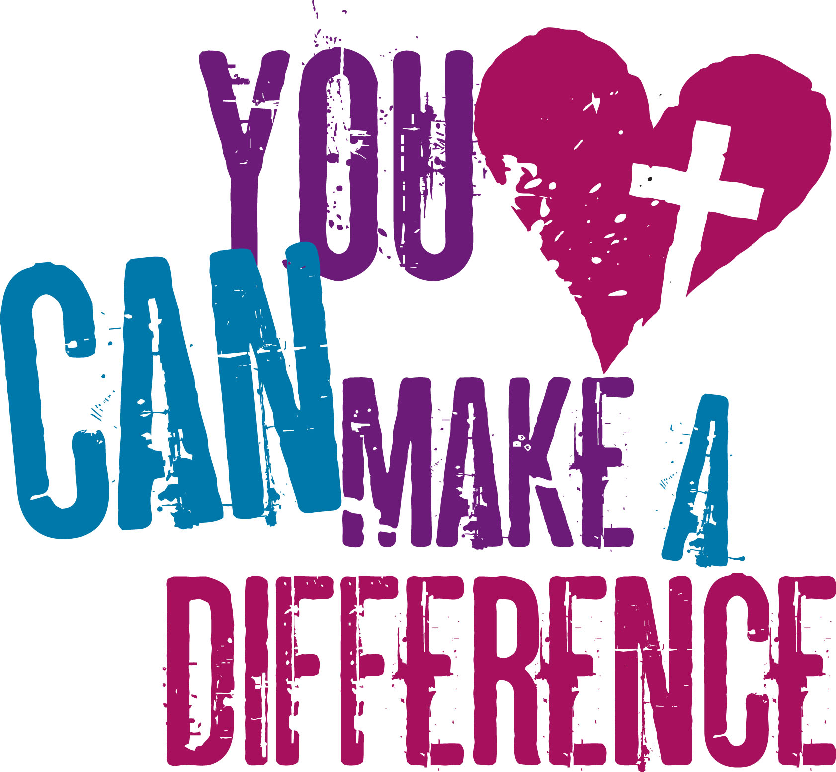

Volunteer of the Quarter:
Melody Noland
Other ways you can help:

*Mail your donation to:
PO Box 424
Great Falls, SC 29055

*Donate through PayPal

*Go to smile.amazon.com when you shop through Amazon and choose GRASP. A portion of your payment will be donated to GRASP.

GRASP is in need of people like you to make a difference in OUR community! We know that everyone has a special talent or skill and if you are looking for a place to make an impact on the lives of your neighbors then look no further. GRASP would love to have you join our team!
We are currently looking for volunteers to help with:
- Answering phones and greeting clients
- Completing client interviews
- Charting and data entry
- Food Pantry
- Special Events
Calling All Churches and Community Members
GRASP works diligently to help our neighbors in need by providing food, utility and prescription assistance. We cannot provide the support needed without assistance from our community partners. Please remember GRASP when you plan your end of year giving, especially if you need to make a donation to help with taxes. Another way to give is to create a legacy or memorial gift by naming GRASP as a beneficiary when you complete your will. This method provides a way for you to make a lasting impact on your community.
Notes from the President
Contact Us:  Grasp  802 dearborn St.  great falls, SC 29055  803-482-4407  graspcrisisrelief@gmail.com  www.graspcrisisrelief.com  Facebook.com/graspcrisisrelief  twitter.com/graspcrisisrelief | OUR SERVICES  - Food pantry (once every 30 days)  - Assistance with utilities  - Assistance with prescriptions (no controlled substances)  - Referrals  Hours of Operation: Monday-Thursday (1:00-4:30)

Volunteer of the Quarter:
Recipient Name
Street Address
City, ST ZIP Code

Wonderful things have been happening at GRASP over the last few months. We are constantly looking for ways that we can impact our community in a positive way. If you have ideas or suggestions about programs GRASP could offer, please let us know.
Also, please check out our executive director who was featured in the video series entitled “What’s in Your Backyard?” which was directed by Chester County Chamber of Commerce. Go to www.chesterchamber.com/careers to see the entire series.

