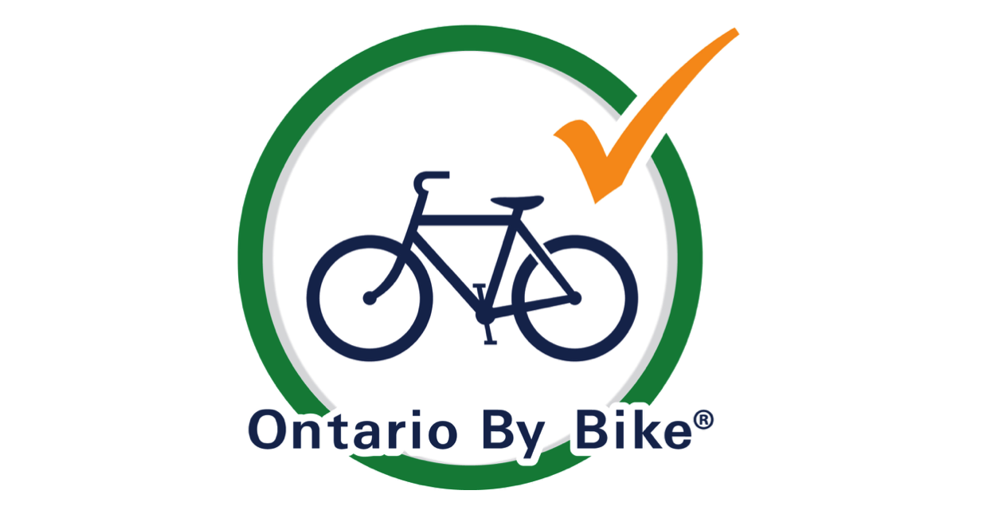

2023 Cycling & Cycle Tourism Survey

Background Info
Ontario By Bike/Transportation Options has completed a number of past primary research projects and published reports that provide partners and stakeholders with valuable insight into the cycling and cycle tourism market.
This 2023 survey will build on past data sets and enable us to create a useful report that will be published and made available to partners.
While we have a large community of cyclists that we can reach through our channels, we are asking for additional assistance from partners, organizations and groups to ensure there is a wide reach and large response rate for the 2023 survey. (The 2021 survey had over 1,200 responses.)

Visit our website: www.ontariobybike.ca
View past research reports at: www.transportationoptions.org/ontarioresearch
To sign up to receive a copy of this research report when complete sign up HERE.

The survey will be open until November 15, 2023.
Please share survey link: www.surveymonkey.com/r/2023CyclingSurvey

Suggested Content for Promotion of Survey
Please feel free to use the below copy or amend as needed and share information with your contacts, followers, communities, as appropriate.
As a cyclist, you may be interested in completing this survey on your cycling and cycle tourism activities in Ontario. https://www.surveymonkey.com/r/2023CyclingSurvey
OR
As a cyclist, you may be interested in completing this survey on your cycling and cycle tourism activities in Ontario. Issued by - tag/link Ontario By Bike – your response is of great value and collectively will provide useful information to our organization as well as other partners. Survey open until November 15. https://www.surveymonkey.com/r/2023CyclingSurvey
OR
(Tag/link) Ontario By Bike – is looking for your input on your cycling activities in Ontario. Take the survey at: https://www.surveymonkey.com/r/2023CyclingSurvey
OR
Make a difference! As a cyclist in Ontario, this survey will be of interest to you. Share insight about your cycling preferences and outings, important info needed to show the value of cycling and cycle tourism in Ontario, and further the work to support future improvements. https://www.surveymonkey.com/r/2023CyclingSurvey

Suggested Image for Inclusion
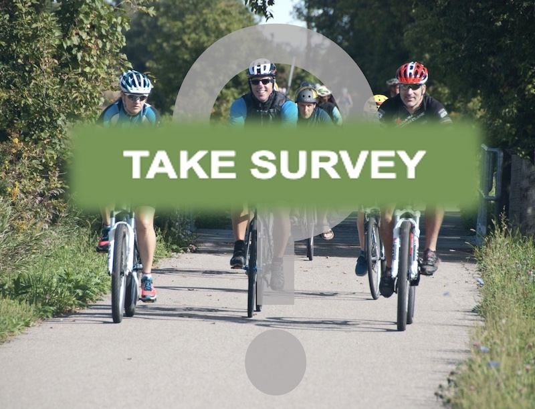
For promotional outreach through social media please tag Ontario By Bike using our SM handles.
∙ Facebook: @ontariobybike
∙ Instagram: @ontario_by_bike

FOR ADDITIONAL ASSISTANCE CONTACT: info@ontariobybike.ca

Thank you in advance, from Ontario By Bike / Transportation Options

