MASS INTENTIONS
Saturday, March 29th - Sunday, April 5th
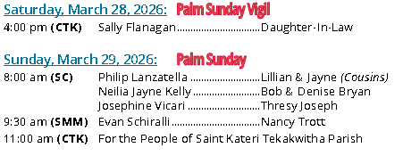
Monday, March 30, 2026:
12:00 pm (CTK) Michael Adkins Family
Tuesday, March 31, 2026:
12:00 pm (CTK) Margaret Mendick Love, her Family
Wednesday, April 1, 2026:
12:00 pm (CTK) For Vocations to the Priesthood
Thursday, April 2: Parish Offices Close at Noon
NO NOON MASS
7:00 pm (CTK) For the People of Saint Kateri Tekakwitha Parish

Friday, April 3: Parish Offices Closed
NO MASS
3:00 pm (CTK) Service: Passion of the Lord with Veneration of the Cross

Saturday, April 4: Easter Vigil
7:00 pm (CTK) For the People of Saint Kateri Tekakwitha Parish

Sunday, April 5: Easter Sunday
8:00 am (SC) For the People of Saint Kateri Tekakwitha Parish
9:30 am (SMM) For the People of Saint Kateri Tekakwitha Parish
11:00 am (CTK) For the People of Saint Kateri Tekakwitha Parish

This week, the Sanctuary Candle at Saint Kateri Tekakwitha Parish at Christ the King Church burns In Memory of Michael Adkins with love from his Family.

