Physical Address Mailing Address
100 E. Second St. 100 E. 2nd St., Suite H
Madison, IN 47250 Madison, IN 47250
(812) 274-0349
hohinfo@cinergymetro.net
www.hohmadison.org
VOLUNTEER NEWSLETTER: December, January, February 2018/2019
Thank you to all the volunteers, our participating churches, local retailers, funders and others who support the House of Hope food pantry! If you have any questions or concerns about your service at the House of Hope, please contact Deb Bunton: (812) 274-0349 or buntond@cinergymetro.net
December 2018 Data  Total families served: 281 (includes 17 first time families)  Total family members: 969  Ages 0-5: 81  Ages 6-17: 198  Ages 18-64: 584  Ages 65+: 106  Our volunteers contributed 1,020 hours in December!  House of Hope appreciates volunteers who participate in the appropriate training to ensure our operations are consistent and safe for all involved. | Guided Shoppers Greatly Needed  This training can be scheduled at your convenience,  call HOH (812) 274-0349 or email:  Deb Bunton: buntond@cinergymetro.net  Guided shoppers help visitors navigate the food pantry and connects the visitor with education opportunities and other social service organizations.  Guided shoppers are an essential component of what makes House of Hope Food Pantry operate smoothly. Consider signing up today!
A Reflection on the Year of 2018  The volunteers at the House of Hope were blessed by the opportunity and privilege of serving 1,312 food insecure families (4,462 family members) living in Jefferson County at least once in 2018. Of this number, 378 were first time families.  Ages 0-5: 465  Ages 6-17: 1005  Ages 18-64: 2703  Ages 65+: 289  The pantry's volunteers generously invested 12,610 hours at the pantry in 2018. Since the pantry does not have any paid staff, each volunteer is a valuable member of the team.  The volunteers extend their appreciation and thanks to everyone who provided food donations, funding and prayer support in 2018. The pantry has been blessed by your support and could not serve their neighbors without you. The House of Hope wishes all of its supporters and guest families a prosperous and Happy New Year. | Thank you to all churches, businesses, schools, clubs and individuals who collect food in support of House of Hope. The need for food drives is important all year long. Please consider donating the following items:  - Cereal and other breakfast items  - Canned fruit and vegetables  - Soup and canned meals  - Canned meats  - Pasta (all kinds) & spaghetti sauce  - Toilet paper and personal hygiene products (shampoo, deodorant, etc.) are needed in particular.
IMPORTANT PROGRAM INFORMATION
FOR HOH CHURCHES, FAMILIES
& VOLUNTEERS
You are invited to participate in these programs!
Questions? Call Erin Lawrence, Resource & Referral Specialist
(812) 274-0983 or elawrence@rivervalleyresources.com
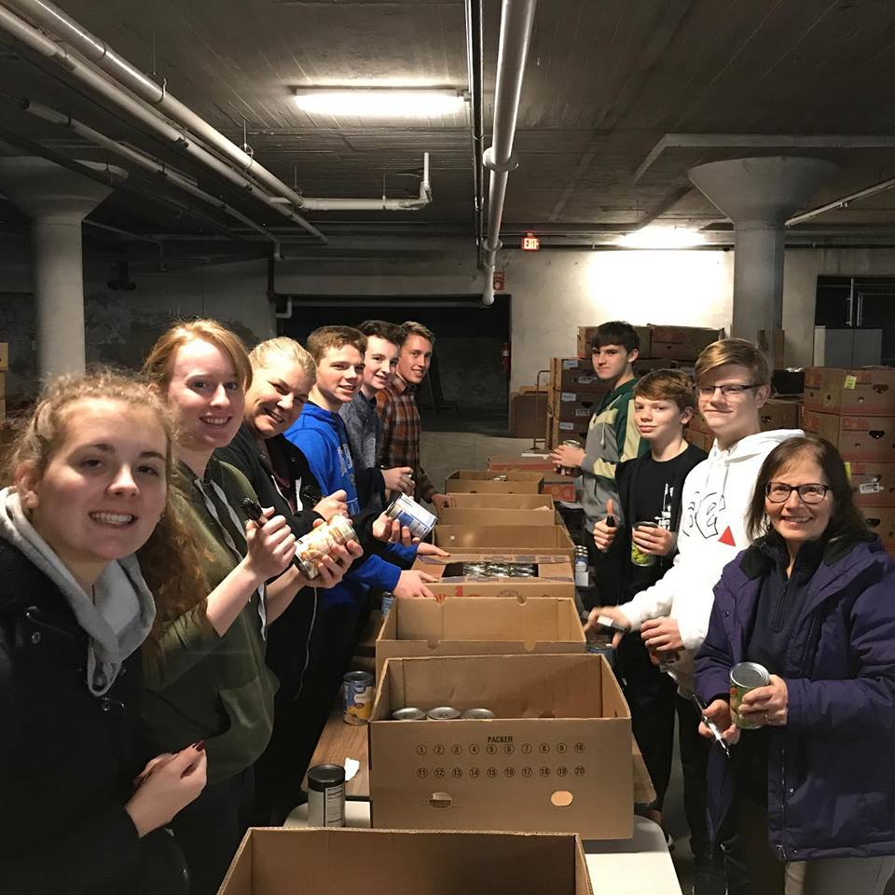  The Cornerstone Baptist Youth Group did a fantastic job of sorting hundreds of canned goods received from recent food drives to benefit the pantry! | Free Legal Clinic  No longer offering services inside the Clearinghouse. Services are now offered over the phone and online. See below for more detail.  Child Care Vouchers  Are you working or enrolled in school and need help paying for child care?  Call River Valley Resources at the Clearinghouse, (855) 591-7848  Adult Education  Earn your high school equivalency diploma, qualify for free training or prepare for college entry. Walk-ins welcome at the Clearinghouse: Monday – Wednesday, 9 a.m. -1 p.m. Monday, Wednesday, 4 p.m. -8 p.m.
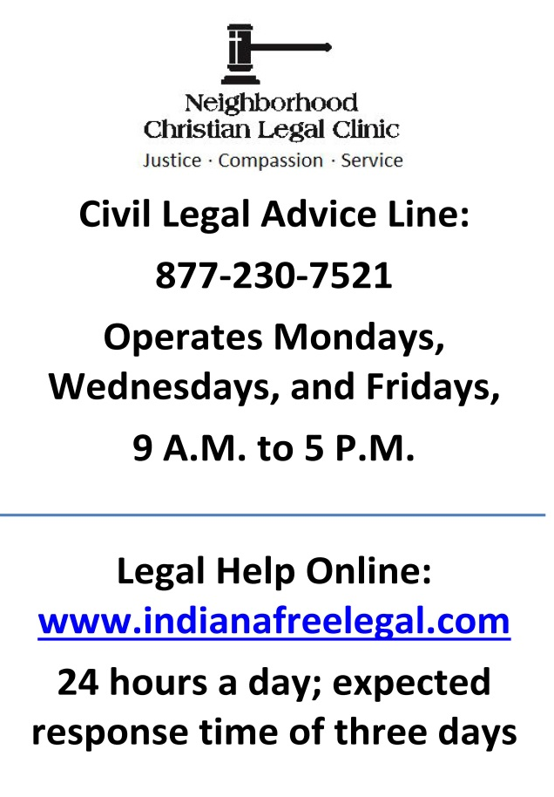 | Plastic bag donations needed!  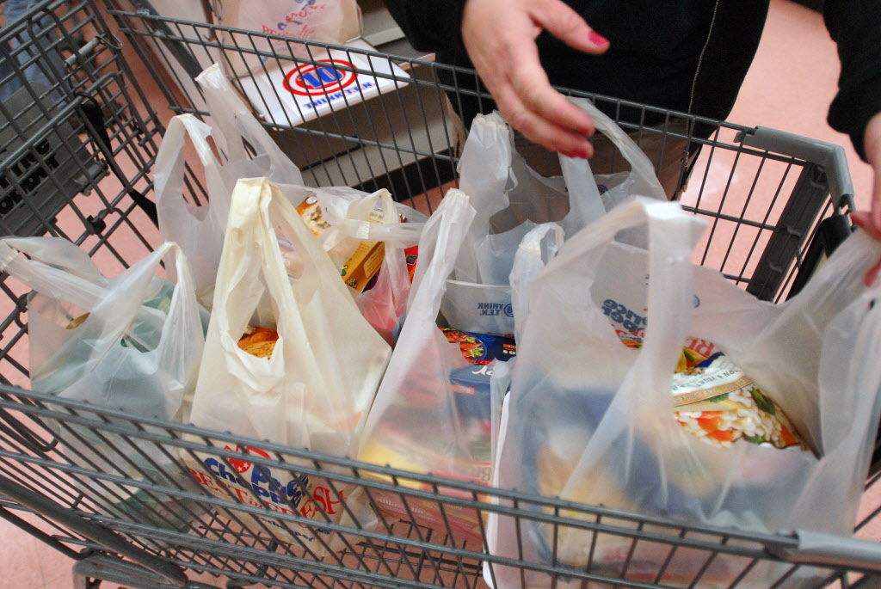  The House of Hope needs plastic bags to help our visitors leave with their goods. Please consider dropping off your bags at the front desk of the Clearinghouse any time Monday through Friday 8 A.M. to 8 P.M.

