FOR IMMEDIATE RELEASE

Contra Costa County Public Works to Install New Traffic Signal at the Intersection of Mt. Diablo Scenic Boulevard and Diablo Road/Blackhawk Road

March 10, 2026, Danville and Diablo, CA - The Contra Costa County Public Works Department, in partnership with Davidon Homes and its contractors, DeSilva Gates and MCH, will be installing a new traffic signal at the intersection of Mt. Diablo Scenic Boulevard and Diablo Road/Blackhawk Road starting Monday, March 16, 2026, through Friday, June 3, 2026, barring unforeseen circumstances. Work will take place from 7:00 a.m. until 5:00 p.m., Monday through Friday, weather permitting. Traffic control will be used. Lane closures will be restricted from 9:00 a.m. to 2:30 pm. Drivers can expect delays of 5-10 minutes.

This project will replace the existing three-way stop signs with a new traffic signal. It will also include operational improvements by adding a dedicated right turn pocket at the T-intersection for southbound Mt. Diablo Scenic Boulevard onto westbound Diablo Road, which allows for the elimination of the existing “sweeping” right turn lane. These improvements are jointly funded by Davidon Homes (as mitigation for its Magee Preserve development), the Town of Danville (traffic mitigation funds), and the County (Local Road Funds – Gas Tax).

Work Area Map
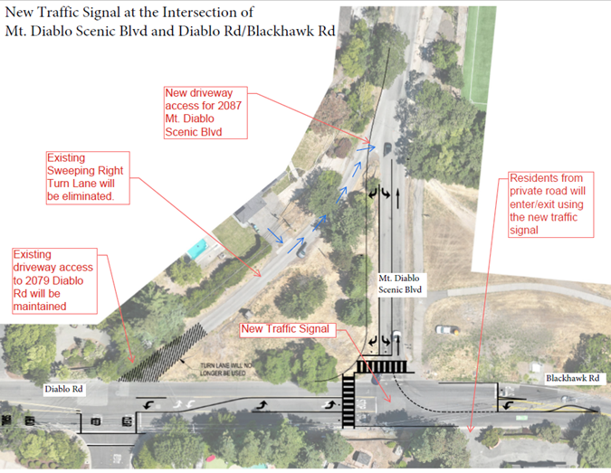

-1-
About Contra Costa County Public Works Department:
The Contra County Public Works Department (CCCPWD) is responsible for the maintenance and operation of over 650 miles of roads, 79 miles of streams and channels, and over 150 County buildings. CCCPWD services include parks and recreation, sandbag distribution, flood control, road and facilities maintenance, and storm water management. CCCPWD operates two airports, Buchanan Field Airport in Concord and Byron Airport in Byron. For more information about CCCPWD, please visit us at: www.cccpublicworks.org

CONTACT: Larry Theis 925.890.9732; Media Inquiries: Kelly Kalfsbeek 925.313.2115
####

-2-

