FOR IMMEDIATE RELEASE

Contra Costa County Public Works to Perform Pavement Repair Work on Diablo Road

September 15, 2026, Diablo, CA – The Contra Costa County Public Works Department will perform pavement repair on Diablo Road between Avenida Nueva and Creekledge Court, starting Monday, September 21, 2026, through Thursday, September 24, 2026, barring unforeseen circumstances. The work will take place between 9:00 a.m. and 3:30 p.m., weather permitting. Message boards will be posted to alert drivers to the work. Traffic control measures will be used. A pilot car will safely direct vehicles through the work area. Road users may experience delays of 10-15 minutes.

Work Area Map
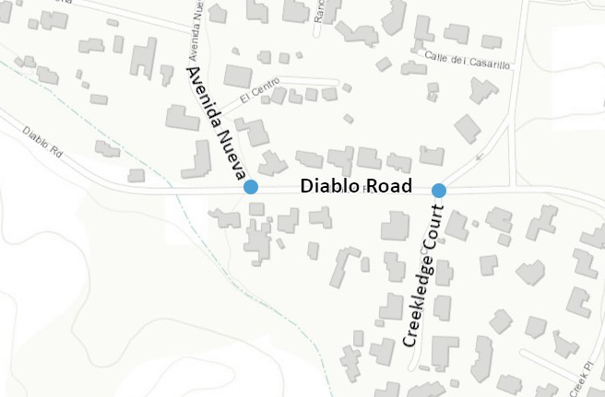

About Contra Costa County Public Works Department:
The Contra Costa County Public Works Department (CCCPWD) is responsible for the maintenance and operation of over 650 miles of roads, 79 miles of streams and channels, and over 150 County buildings. CCCPWD services include parks and recreation, sandbag distribution, flood control, road and facilities maintenance, and storm water management. CCCPWD operates two airports, Buchanan Field Airport in Concord and Byron Airport in Byron. For more information about CCCPWD, please visit us at: www.cccpublicworks.org

CONTACT: Kevin Harbrecht, 925.313.7031; Media Inquiries: Kelly Kalfsbeek, 925.313.2115
####

