FOR IMMEDIATE RELEASE

Contra Costa County Public Works to Perform Road Work on Pinehurst Road

(Updated) October 29, 2025, Canyon, CA – The Contra Costa County Public Works Department will continue performing road work on Pinehurst Road near mile marker 4.8, located approximately 750 ft southeast from the intersection with Skyline Boulevard and Manzanita Drive, through Thursday, November 6, 2025, barring unforeseen circumstances. Work will occur from 9:00 a.m. to 3:30 p.m., Monday through Thursday, weather permitting.

Pinehurst Road will be closed to all traffic between Canyon Road and Skyline Boulevard during working hours. Electronic Message Boards will be used to alert drivers and cyclists to the work. Road users will need to use alternate routes.

Work Area Map
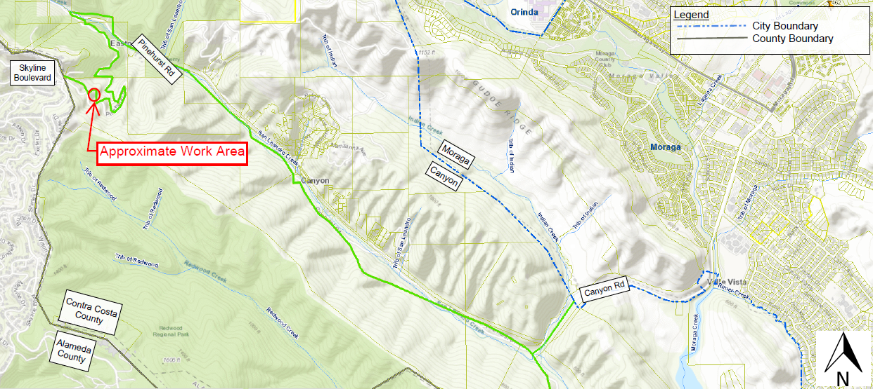

About Contra Costa County Public Works Department:
The Contra County Public Works Department (CCCPWD) is responsible for the maintenance and operation of over 650 miles of roads, 79 miles of streams and channels, and over 150 County buildings. CCCPWD services include parks and recreation, sandbag distribution, flood control, road and facilities maintenance, and storm water management. CCCPWD operates two airports, Buchanan Field Airport in Concord, and Byron Airport in Byron. For more information about CCCPWD, please visit us at: www.cccpublicworks.org.

CONTACT: Caroline Tom, 925.313.7007; Media Inquiries: Kelly Kalfsbeek 925.313.2115
####

