FOR IMMEDIATE RELEASE

Contra Costa County Public Works to Perform Tree Removal Work Along Danville Boulevard

February 25, 2026, Alamo, CA – A contractor for Contra Costa County Public Works will perform tree removal operations along Danville Boulevard starting Monday, March 2, 2026, through Friday, March 6, 2026, barring unforeseen circumstances. Work will take place between Hillgrade Avenue and Jackson Way (Work Area 1) and Camille Avenue and Las Trampas Road (Work Area 2). Work will occur between 9:00 a.m. and 4:00 p.m., weather permitting. Traffic control will be used. Drivers can expect delays of 5–10 minutes.

This work will enhance public safety along Danville Boulevard by removing dead trees using a two-step process. During the first step, all branches will be removed, with complete tree removal taking place the following day.

Contra Costa County Public Works, Special Districts, has worked with an arborist to develop a tree management plan for the area. This will be the fourth of five phases of a planned multi-year project along Danville Boulevard that follows the tree management plan.

Work Area 1 Map
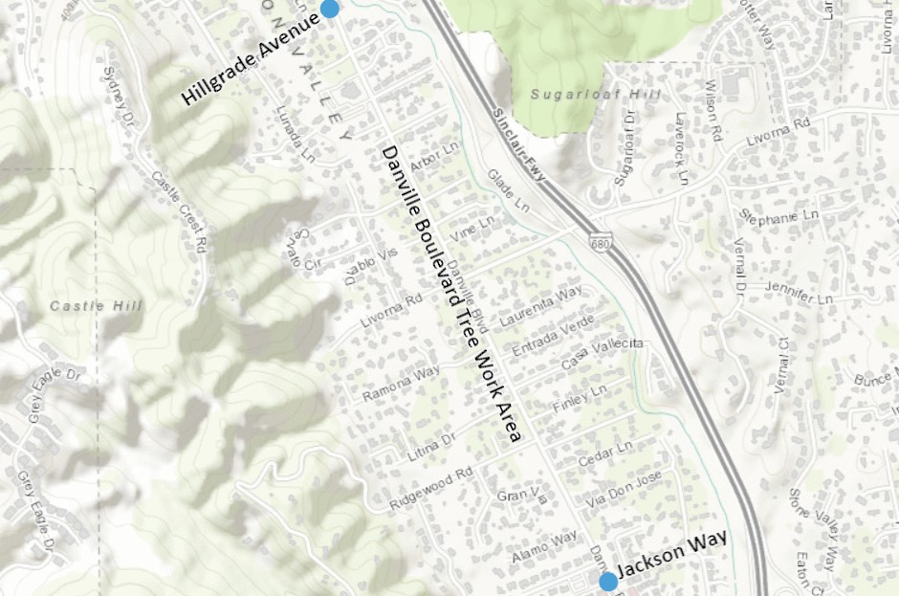

-1-
Work Area 2 Map
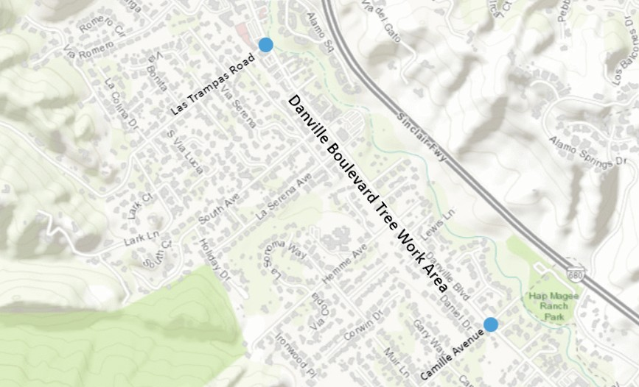

About Contra Costa County Public Works Department:
The Contra Costa County Public Works Department (CCCPWD) is responsible for the maintenance and operation of over 650 miles of roads, 79 miles of streams and channels, and over 150 County buildings. CCCPWD services include parks and recreation, sandbag distribution, flood control, road and facilities maintenance, and storm water management. CCCPWD operates two airports, Buchanan Field Airport in Concord and Byron Airport in Byron. For more information about CCCPWD, please visit us at: www.ccpublicworks.org

CONTACT: Jeryck Acuña, 925.313.2272; Media Inquiries: Kelly Kalfsbeek 925.313.2115
####

-2-

