September 12, 2025
Dear Community Partner,
The Contra Costa County Board of Supervisors has a unique opportunity to invest $1 million in Community Impact Funds specifically for District 2, which includes the San Ramon Valley, Lamorinda, and parts of Walnut Creek.
This is an important chance for you to help shape investments that directly support our neighborhoods. I want to hear directly from residents and organizations like you so we can work together to identify and address the most pressing needs in our community.
The Community Impact Fund is made possible through some remaining funds the County had from the American Rescue Plan Act (ARPA). Contra Costa County received $307 million during the pandemic, and out of caution, a portion of those funds was held in reserve while we waited for FEMA reimbursements for COVID-19-related expenses.
Now that the County has received final reimbursements from FEMA, the remaining funds ($29.6 Million) have been used to establish the Community Impact Fund. We are reinvesting these funds back into our communities. In June 2025, the Board of Supervisors approved spending $1 million per Supervisorial District, totaling $5 million, for projects that reflect local needs and priorities.
These funds can be used for a wide range of initiatives, including:
- Infrastructure (roads, streets, bridges)
- Public transportation
- Affordable housing
- Public safety
- Childcare
- Health and wellness
- Senior services
- Food security
- Economic development
- Youth services
In addition to these district-specific allocations, during the budget process the Board of Supervisors chose to use this money to fund the following:

- $3.5 million for the SAFE (Services and Access for Everyone) Center
- $2.2 million for Stand Together Contra Costa
- $400,000 for Refugee Resettlement Programs

If you or your organization is interested in applying for funding, please submit an application using one of the following methods:
- Paper Application: Fill out and return to Supervisor Andersen’s Office at:
309 Diablo Road, Danville, CA 94526

- Online Application:


Please feel free to share this invitation with other community members. Your voice and participation are essential in making sure these funds are used in ways that truly reflect our local values and priorities.
I look forward to seeing you at an upcoming Town Hall and working together to make a lasting, positive impact in District 2.
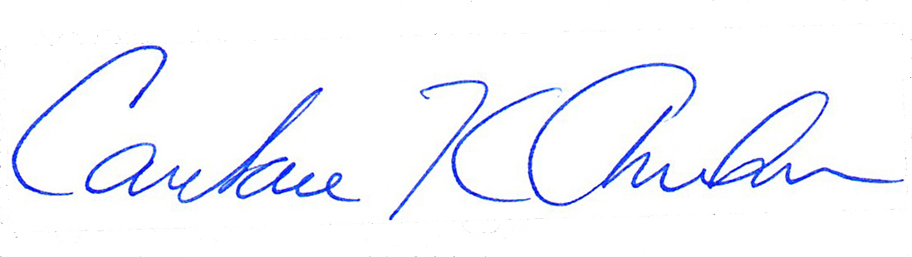
Warm regards,

Candace Andersen, Supervisor
Contra Costa County, District 2

