FOR IMMEDIATE RELEASE

Contra Costa County Public Works to begin Construction of the Springbrook Road Culvert and Sinkhole Repair Project

September 21, 2026, Walnut Creek and Lafayette, CA – Contra Costa County Public Works will perform construction of the Springbrook Road Culvert and Sinkhole Repair project along Springbrook Road near the intersection of Sherwood Way, from Thursday, September 24, 2026, through Friday, November 20, 2026, barring unforeseen circumstances. Work will occur between 7:00 a.m. and 5:00 p.m., Monday through Friday, excluding holidays, weather permitting.

This project is designed to repair a damaged culvert and sinkhole under Springbrook Road. The work consists of removing a 36” CMP and installing 36” RCP, cast in place 4’ x 3’ box culvert, drainage structures, and roadway reconstruction. Funding for the project is provided by Federal Emergency Relief Funds and Local Road Funds. For more information, visit https://www.contracosta.ca.gov/10282/Springbrook-Road-Culvert-and-Sinkhole-Re.

A road closure for through traffic from east of Sherwood Way to just south of the project site will be in effect during construction hours. A detour for through traffic will be posted and delays for fronting properties of up to 15 minutes will be in place. Message boards and other posted signage will alert drivers to the work. Drivers should expect delays through the work zones and consider alternative routes during working hours.

Work Area and Detour Map
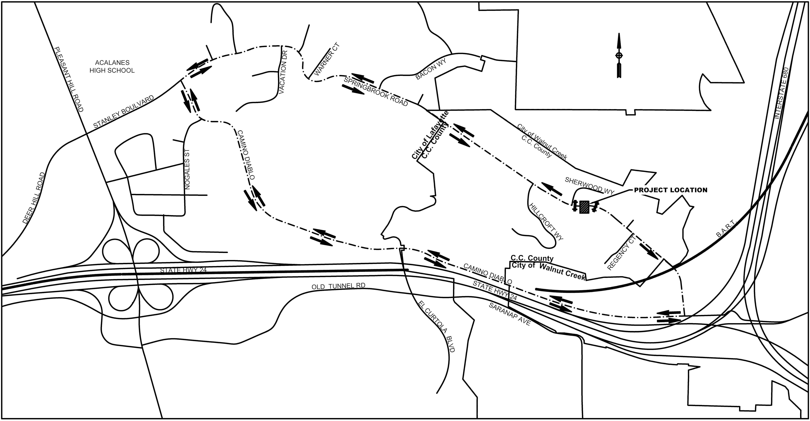

1
About Contra Costa County Public Works Department:
The Contra Costa County Public Works Department (CCCPWD) is responsible for the maintenance and operation of over 650 miles of roads, 79 miles of streams and channels, and over 150 County buildings. CCCPWD services include parks and recreation, sandbag distribution, flood control, road and facilities maintenance, and storm water management. CCCPWD operates two airports, Buchanan Field Airport in Concord and Byron Airport in Byron. For more information about CCCPWD, please visit us at: www.cccpublicworks.org

CONTACT: Construction: Nick Panayotou, 650.642.5299;
Media Inquiries: Kelly Kalfsbeek, 925.313.2115
####

2

