FOR IMMEDIATE RELEASE

Contra Costa County Public Works to Perform Pavement Repair Work in Danville

August 12, 2026, unincorporated Danville, CA – The Contra Costa County Public Works Department will perform pavement repair work on Diablo Road between Avenida Nueva and Creekledge Court (Work Zone 1) and on Blackhawk Road between Magee Ranch Road and east of Oakridge Lane (Work Zone 2), starting Monday, August 24, 2026, through Thursday, September 10, 2026, barring unforeseen circumstances. The work will take place between 8:00 a.m. and 5:00 p.m., Monday through Thursday (excluding holidays), weather permitting. Message boards will be posted to alert drivers to the work. Traffic control measures will be used. A pilot car will safely direct vehicles through the work area. Road users may experience delays of 10-15 minutes.

Work Zone 1 Area Map
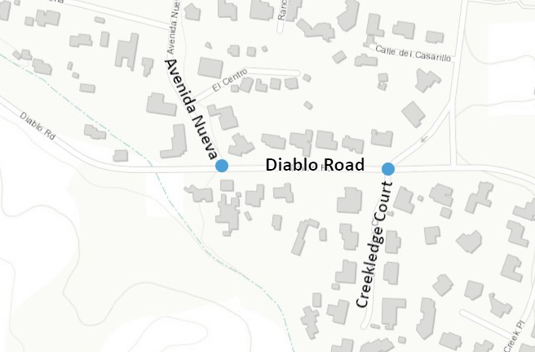

-1-
Work Zone 2 Area Map
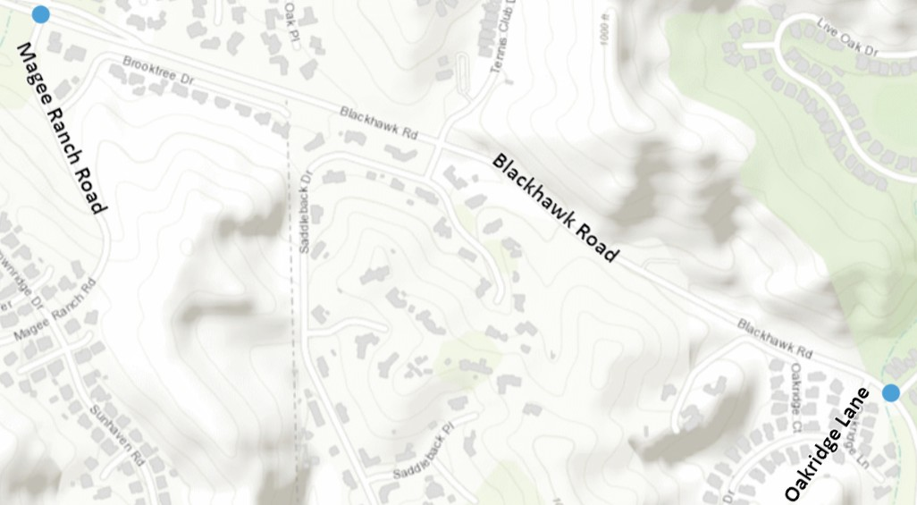

About Contra Costa County Public Works Department:
Contra Costa County Public Works Department (CCCPWD) maintains over 650 miles of roads, 79 miles of streams, channels, and other drainage, and over 150 County buildings throughout Contra Costa County. CCCPWD provides services such as Parks and Recreation, Sandbag Distribution, and Flood Control throughout the unincorporated areas of Contra Costa County. CCCPWD operates two airports, Buchanan Field Airport in Concord and Byron Airport in Byron. For more information about CCCPWD, please visit us at www.cccpublicworks.org

Contact: Kevin Harbrecht, 925.313.7031; Media Inquiries: Kelly Kalfsbeek, 925.313.2115
####

-2-

