FOR IMMEDIATE RELEASE

Contra Costa County Public Works to Perform Delineator Replacement Work on San Pablo Dam Road

March 12, 2026, unincorporated Orinda, CA – The Contra Costa County Public Works Department will replace delineators to enhance safety on San Pablo Dam Road, between Tri Lane and Wildcat Canyon Road, starting Monday, March 23, 2026, through Thursday, March 26, 2026, barring unforeseen circumstances. The work will occur from 8:00 a.m. through 3:30 p.m., weather permitting.

The work will be scheduled to minimize impacts to commute traffic. Message boards will be posted to advise drivers of the scheduled work. A pilot car will be used to direct traffic through the work area. Drivers can expect delays of 10-15 minutes and are encouraged to use alternative routes.

Work Area Map
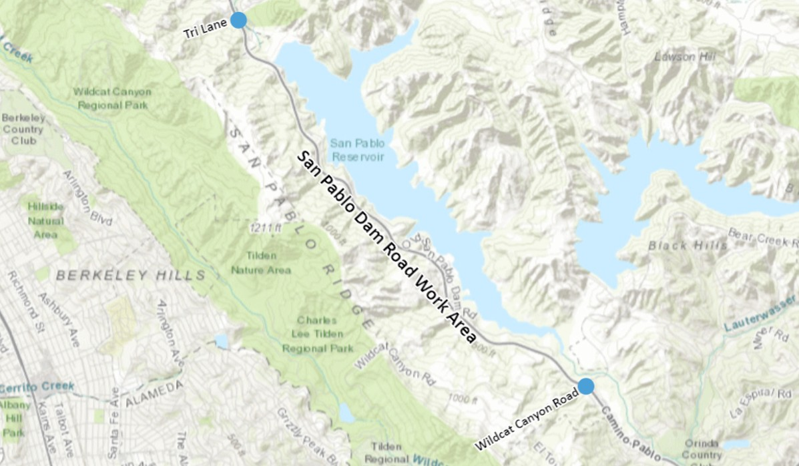

About Contra Costa County Public Works Department:
The Contra County Public Works Department (CCCPWD) is responsible for the maintenance and operation of over 650 miles of roads, 79 miles of streams and channels, and over 150 County buildings. CCCPWD services include parks and recreation, sandbag distribution, flood control, road and facilities maintenance, and storm water management. CCCPWD operates two airports, Buchanan Field Airport in Concord and Byron Airport in Byron. For more information about CCCPWD, please visit us at: www.cccpublicworks.org

CONTACT: Chris Griffin 925.313.7046; Media Inquiries: Kelly Kalfsbeek 925.313.2115
####

