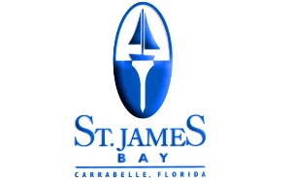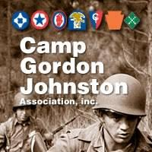

2019 CAMP GORDON JOHNSTON MUSEUM BENEFIT GOLF TOURNAMENT
Saturday, December 7, 2019 – 9:00 AM Shotgun
Format: 4 (four) Player Select-a-shot, Captain’s Choice or Team Scramble
Note: All 18 Holes will be played as Par 3’s
Entry Fee: $320.00/Team (80.00/Player) includes Greens Fees, Cart Fees, Range Balls and Lunch
Deadline: Field is Limited to first 24 Teams of 4 Players
TO PAY BY CHECK, PLEASE MAKE PAYABLE AND SEND TO:
St James Bay Golf Resort
151 Laughing Gull Lane
Carrabelle, FL 32322
TO PAY BY CREDIT CARD, PLEASE CALL THE GOLF SHOP @ ST JAMES BAY:
(850)697-9606
FOR MORE INFORMATION, PLEASE CONTACT GREG SEIDEL-GSeidel@KemperSports.com

PLAYER:___________________________________________________________
PLAYER:___________________________________________________________
PLAYER;___________________________________________________________
PLAYER:___________________________________________________________

