ECE 695 Graduate Seminar Announcement
Electrical and Computer Engineering Department Seminar
Monday, April 1, 12:00 noon-1pm, 306 Lutz Hall

Adaptive System Identification and Control Theory
for Precise Personalized Drug Delivery
Speaker: Dr. Tamer Inanc

Summary:
Tools that are used to determine the dose of a drug to deliver to a patient range from specific instructions contained in the drug package insert to tools used by pharmacists for the dosing of aminoglycoside antibiotics. In the case of the latter, physicians have been fairly accurate since there is sufficient information about the pharmacokinetics of the aminoglycosides and, combined with peak and trough drug levels, useful dose recommendations can be provided. In the case of the former, often physicians are left to a form of trial-and-error dosing in which adjustments are made to the dose as the results are observed for each specific patient. The current system works for the drugs which have a wide therapeutic window or mild toxicity. However, when faced with a drug that has a narrow therapeutic window, high toxicities, large inter-patient variability or significant dosing restrictions, it becomes difficult for the practitioner to determine what dose of the drug to give. Often these agents are only given successfully by a few specialized individuals with the clinical expertise to manage these patients. This process is inherently imprecise and advances in engineering may help to alleviate much of the uncertainty when dosing these agents. This talk will present a new methodology for the development of adaptive personalized patient dose-response models from a limited number of patient-specific clinical data and a novel control approach for personalizing drug dosing with applications to
anemia and warfarin management. The successful completion of the proposed research has the potential to result in a new method for personalized drug dosing that can be applicable to other chronically administered drugs that require some type of monitoring.
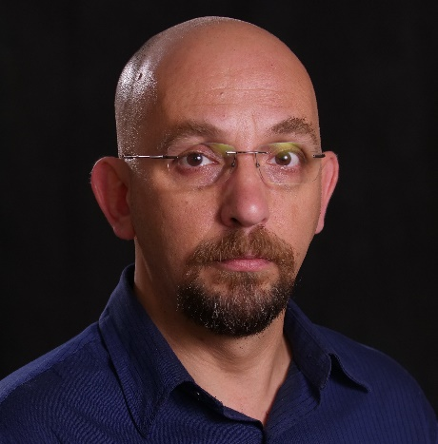 | Biography:  Tamer Inanc received M.S. and Ph.D. degrees in Electrical Engineering from the Pennsylvania State University, PA in 1996 and 2002, respectively. Between 2002 and 2004, he was a postdoctoral scholarship at the California Institute of Technology, Pasadena, CA. He started working as an Assistant Professor in 2004 at the Electrical and Computer Engineering Department at UofL. He is currently Professor at the same department. Dr. Inanc received the President's Distinguished Teaching Professor Award (2022), the Speed School Excellence in Teaching Award (2021), the Delphi Center “Innovations in Technology Award for Teaching and Learning” (2008) and the Kentuckiana Metroversity Instructional Development Award (2006). His research interests center on control systems, model identification, autonomous robotics, and applications of system identification and control systems to biomedical problems.
Contact person: Jacek Zurada, jacek.zurada@louisville.edu

