Graduate Seminar Announcement
Electrical and Computer Engineering Department Seminar
Monday, April 22, 12:00 noon-1pm, 306 Lutz Hall

Medical Imaging and AI – A Remarkable Combination for Advancing Human Health
Speaker: Dr. Amir Amini

Summary:
Medical Imaging has achieved an unprecedented capability to identify diseases within the human body. Thanks to advancement in AI technology over the last decade, in many instances, AI can now diagnose conditions or extract insights from images with a level of proficiency comparable to expert human observers. This not only lessens the workload on physicians in interpreting extensive imaging data, typically collected from each subject, but also has the potential to diminish the need for invasive biopsies. Additionally, it enables the extraction of physiologic information from data not previously accessible. In this talk, I will give an overview of a few projects being carried out at the Medical Imaging Lab, each aimed at addressing these topics.

Speaker:
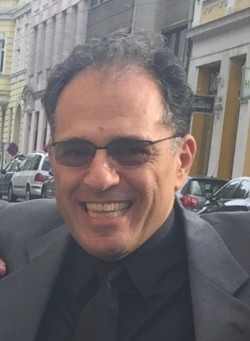
Amir Amini is Endowed Chair in Bioimaging and Professor of Electrical and Computer Engineering at the University of Louisville. His prior faculty appointments were at Yale and Washington University in St. Louis. He has had leadership roles in organization of numerous conferences in medical imaging and image analysis as scientific program committee member, scientific program chair, as well as conference chair, and was symposium co-chair of SPIE Medical Imaging in 2007 and the IEEE International Symposium in Biomedical Imaging in 2018. He currently serves as Associate Editor for IEEE Transactions on Medical Imaging, IEEE Trans. On Biomedical Engineering, IEEE Reviews in Biomedical Engineering, IEEE Open Journal of Engineering in Medicine and Biology, and Computerized Medical Imaging and Graphics. He served as Vice President for Publications for the IEEE Engineering in Medicine and Biology Society in 2020-21. Under funding from the NIH, NSF, private foundations, and industry, his laboratory has conducted research in development and application of MRI methods for motion and flow measurement and has developed biomedical image processing and analysis methods based on Deep Learning with applications to cardiovascular imaging, computer aided diagnosis, and radiation therapy of lung cancer. He received the UMASS/Amherst College of Engineering Distinguished Alumni Award in 2020. He was elected a Fellow of the IEEE in 2007, to the College of Fellows of the American Institute for Medical and Biological Engineering in 2017, SPIE, the International Society of Optics and Photonics, in 2018, and the Asia-Pacific Artificial Intelligence Association in 2021.

Contact person: Jacek Zurada, jacek.zurada@louisville.edu

