Greensboro's New Program Assistant: Abby Corcoran

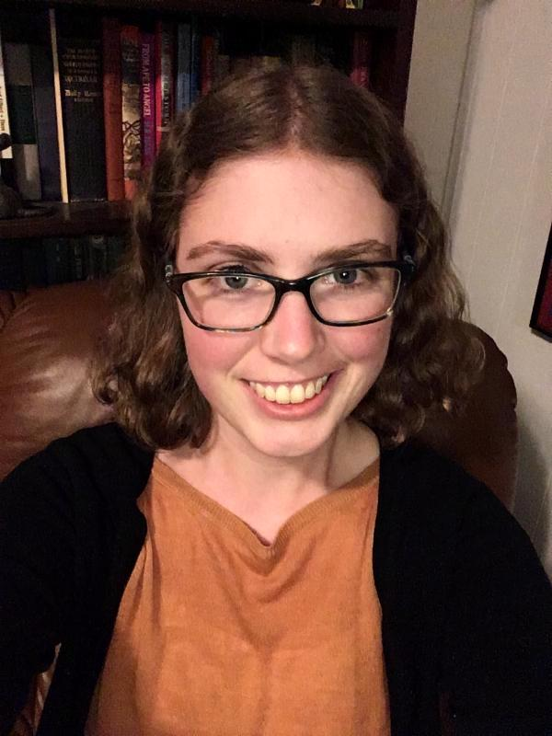
Abby Corcoran was born and raised in Greensboro, NC. She went to Haverford College in Philadelphia, Pennsylvania. She loved visiting all the historical sites in Pennsylvania. However, she could not stay away from Greensboro for too long, so she decided to come back! She was inspired to get involved with Reading Connections by her experiences as a peer tutor in her college writing center. She learned that she not only loves reading and writing but talking to others about it! She will be working alongside John Storm as the new Program Assistant!

Favorite Books?
Her two favorite books are Sea of Poppies by Amitav Ghosh, which is a historical fiction about the Opium Wars in the 1830s and 1840s, and Gaudt Night by Dorothy L. Sayers, which is a mystery set at an Oxford women's college in the 1930s.

Greensboro's New Administrative Assistant/ Program Assistant: Sun H

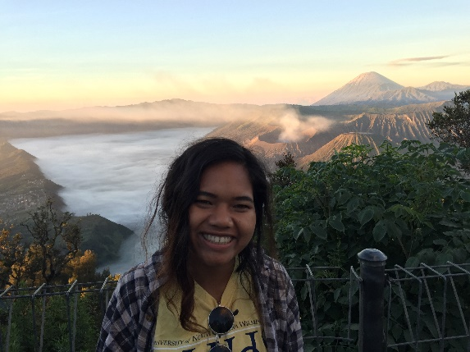
Sun was born in the central highlands of Vietnam, lived in a refugee camp in Cambodia for two years and came to Greensboro when she was seven years old in 2002. She is Montagnard, an encompassing term for all of the indigenous tribal groups located in the highlands of Vietnam. She graduated from Page High School and got her Bachelor of Arts in Psychology and International Studies at UNC-Wilmington. She is our new administrative assistant/program assistant at the Reading Connection's office in Greensboro!

Fun Fact
Sun loves traveling and has backpacked across Europe and Southeast Asia. Her favorite country that she has visited is Indonesia! She is hoping to visit Sri Lanka, Cambodia, China and India in the next couple of years.

