Summer Camp Sneak Peak

We still have spots open for Summer Camp! Check out just a few of the fun filled activities we have planned for this summer!

Camp 1 (ages 3-7): July 8th – July 12th
Barnyard Roundup: Campers will experience life on the farm this week! Children will participate in barnyard activities and visit the Calgary Zoo.

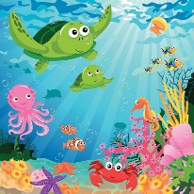
Camp 2 (ages 3-7): July 15th –July 19th
Under the Sea: Children will dive deep this week and learn about creatures under the sea. There will be ocean themed sensory activities, games, and a visit to Build a Bear Workshop.

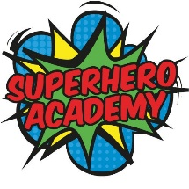
Camp 3 (ages 6-12): July 22nd –July 26th
Superhero Academy: Complete training at our Superhero Academy! Children will engage in skill testing challenges and learn from Calgary Police Officers in what it is like to be a real life superhero. CAMP IS FULL


Camp 4 (ages 6-12): Monday, July 29th – Friday, August 2nd
Outdoor Adventure: Come and get ready for a week filled with adventure both inside and outdoors! Children will get to visit the Zoo and have an afternoon, indoor camping trip, complete with tents and s’mores.


Camp 5 (ages 6-12): August 6th – August 9th
Christmas: Come celebrate wintery fun in the middle of summer! Children will engage in fun holiday themed activities, make ice cream, and even take a trip to Build a Bear workshop.

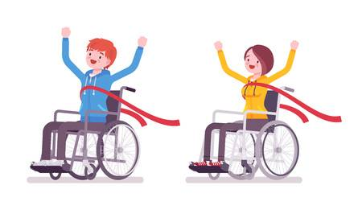
Camp 6 (ages 11-17): August 12th – August 16th
Amazing Race: This week, teens will complete some amazing races around the city! Two of the locations include Chinook Mall and Studio Bell. All campers are winners this week! CAMP IS FULL

